## 

## **AMERICAN INTERNATIONAL UNIVERSITY -BANGLADESH**

**INTRODUCTION TO DATA SCIENCE**

## **Spring- 2024-2025**

**Supervise By**

Tohedul Islam

**Mid Term Project Report**

**Group No: 04**

**Section: F**

**Submitted By:**

|  |  |
| --- | --- |
| **NAME** | **ID** |
| MD.SHANJID HASAN ABIR | 22-47202-1 |
| MD.RIFAT AL MOSTAKIM | 22-46611-1 |
| MD. BAHAUDDIN SAKIB | 22-46093-1 |
| NUR-E HABIB NURSHED | 22-46702-1 |

**Introduction:**

The Diabetes prediction dataset is a collection of medical and demographic data from patients, along with their diabetes status (positive or negative). The dataset consists of **122 rows** and **9 columns**, including a combination of **categorical** and **numeric** attributes. The **categorical attributes** are **gender** (Nominal: Female, Male), **smoking_history** (Nominal: never, current, No Info), and **blood_glucose_level** (Ordinal, although it contains numeric values categorized into ranges). The **numeric attributes** include **age** (Continuous, Numeric), **hypertension** (Binary, Numeric), **heart_disease** (Binary, Integer), **bmi** (Continuous, Numeric), and **HbA1c_level** (Continuous, Numeric). The **target variable** is **diabetes**, which is a **binary variable** indicating whether the individual has diabetes (1) or not (0). The dataset has some missing values that need to be handled, and outliers may need to be detected and removed. Additionally, normalization of continuous attributes like **age, bmi,** and **HbA1c_level** will be performed to prepare the dataset for further analysis and modeling.

**Data Exploration:**

**Import the dataset:**

The dataset is saved as the myDatasheet.csv file. To begin preprocessing data in R studio, we must first import the file.

***Code:***

myDatasheet<- read.csv("/Users/bahauddinsakib/Downloads/Diabetes_Prediction.csv",header=TRUE,sep=",")

myDatasheet

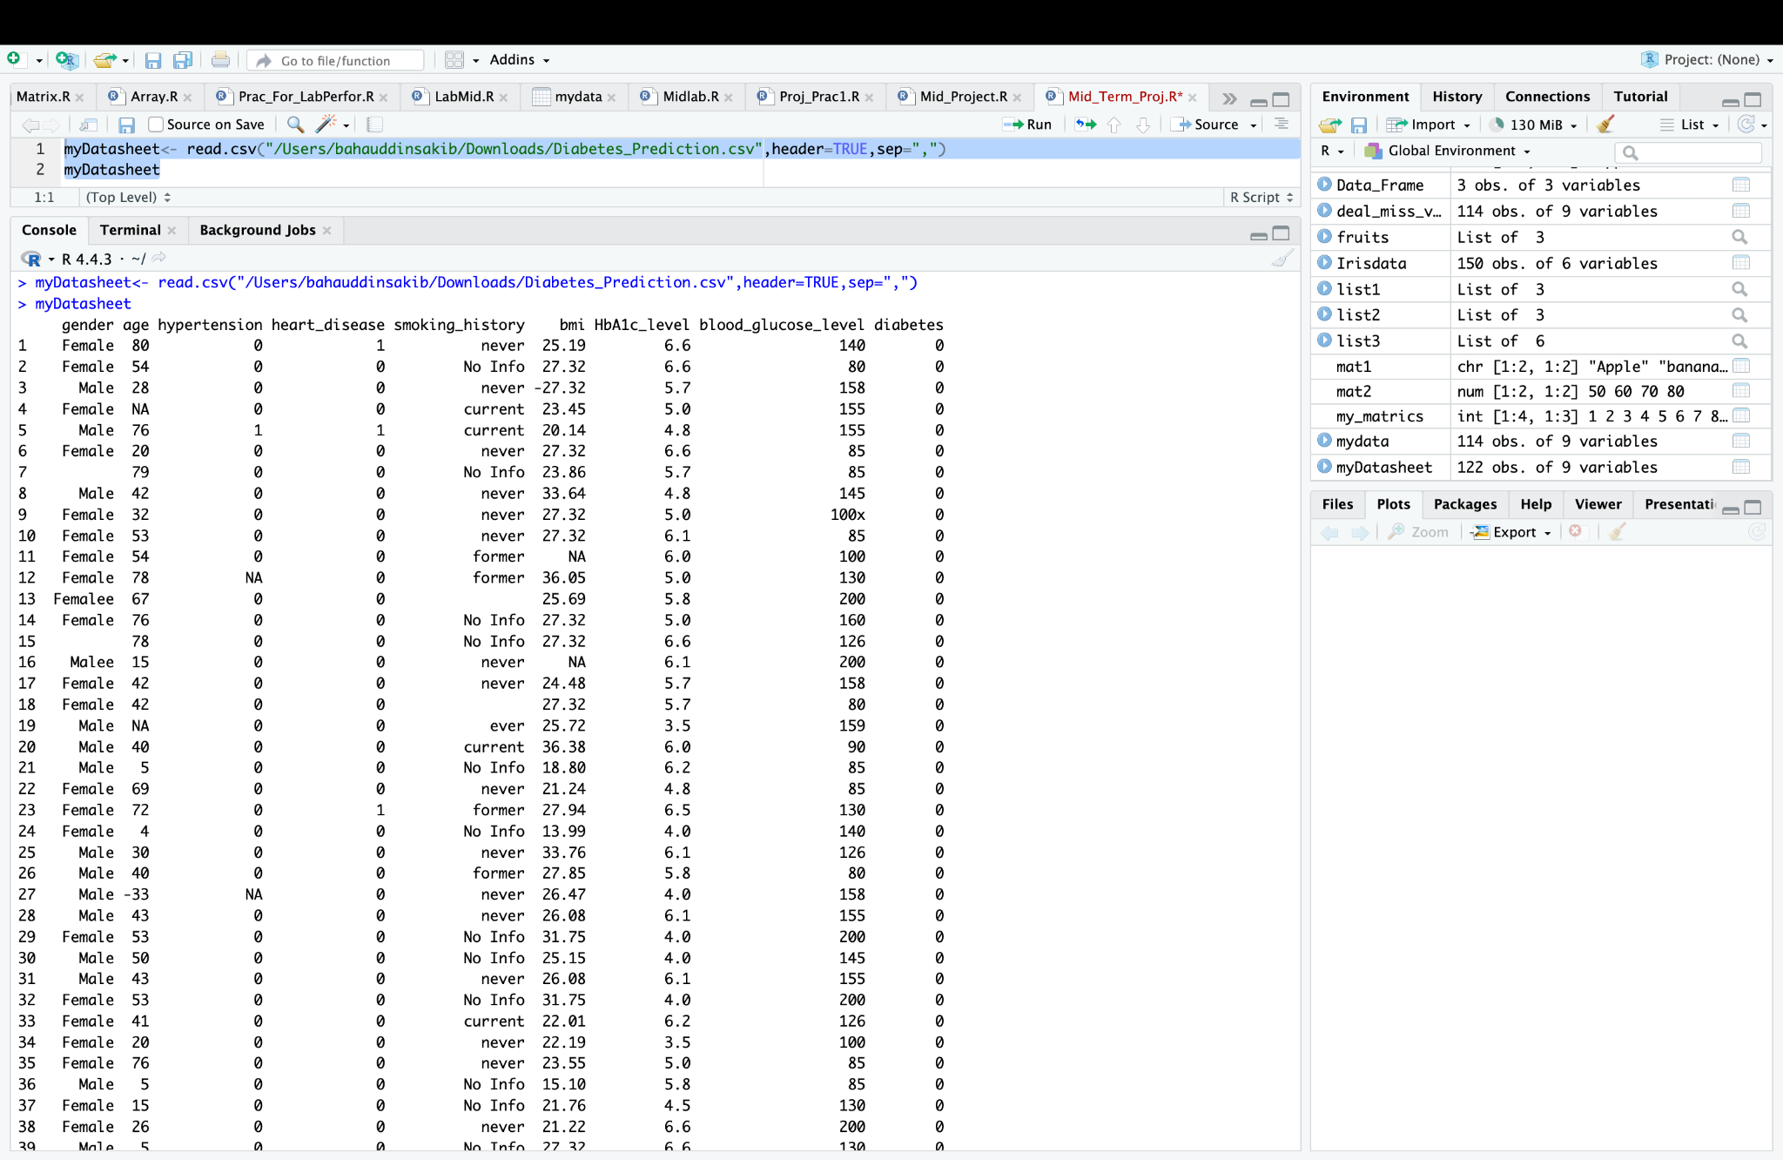

Fig: Imported Raw Dataset

After importing the dataset, the data is converted into a R data-frame and is stored in the data variable. Let’s see the overall summary of the dataset.

**Summary of the dataset:**

***Code:***

summary(myDatasheet)

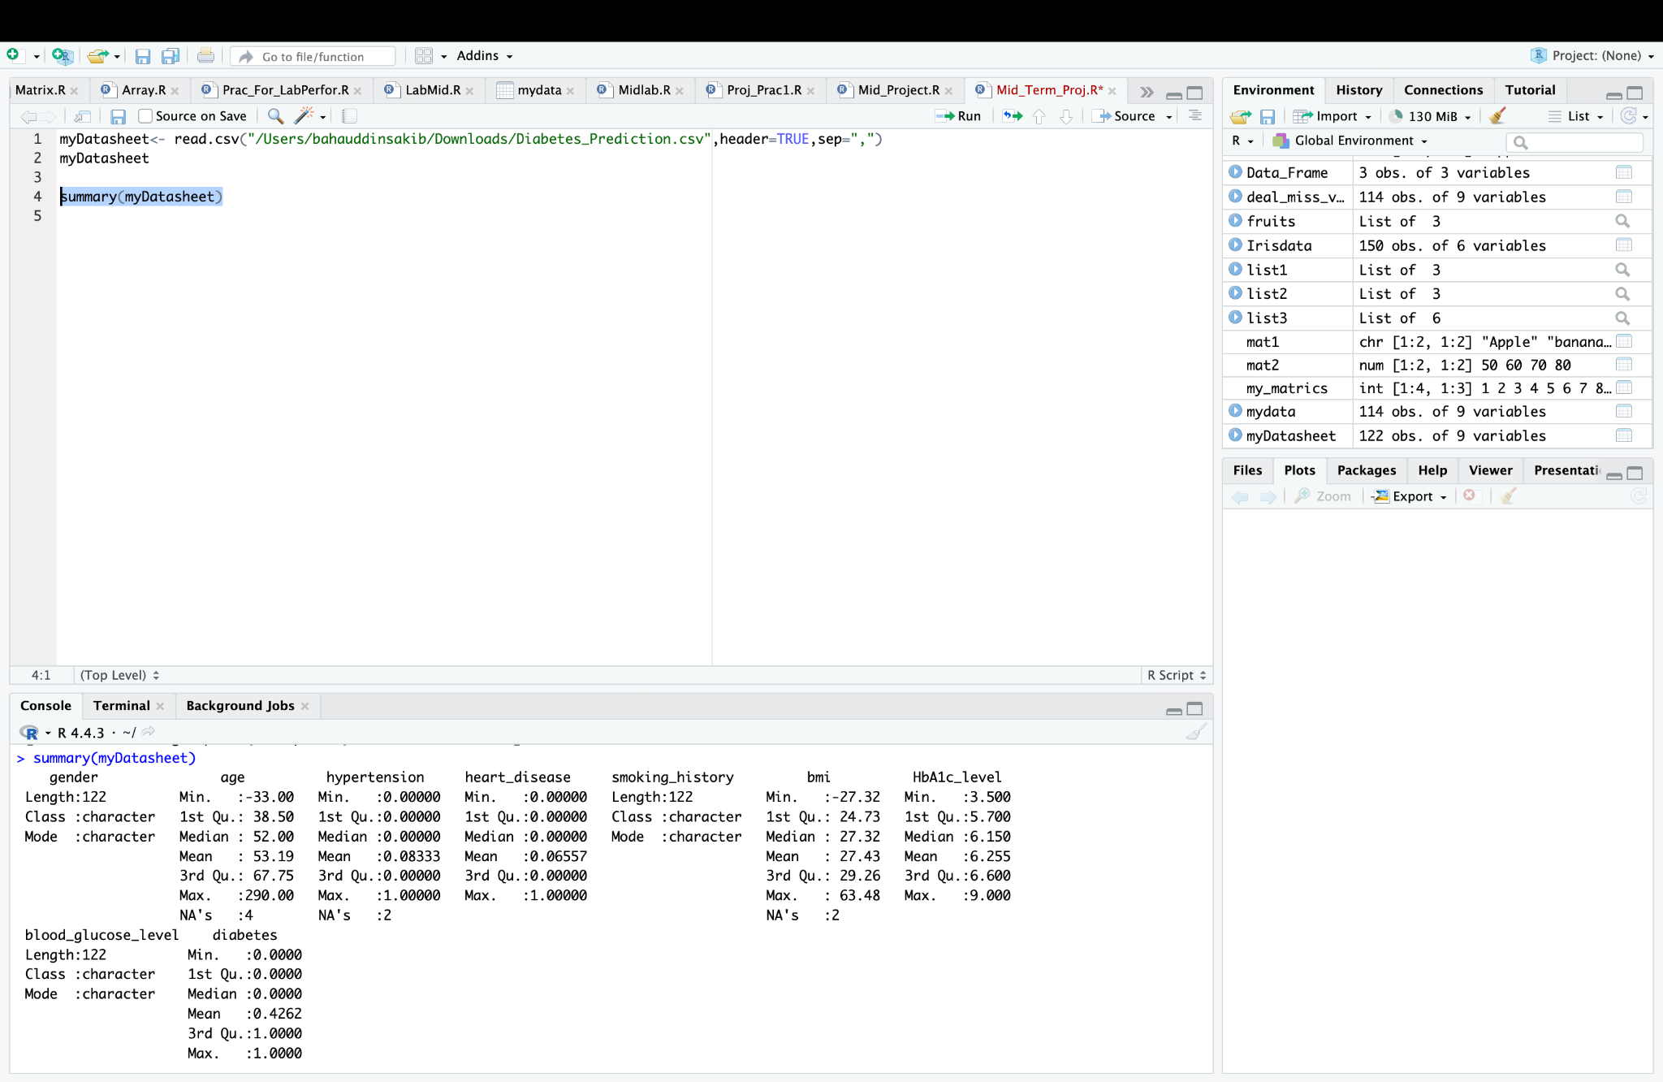

Fig: Summary of Raw Dataset

In the summary we can see the dataset has 9 attributes where some attributes have missing values.

Now, let’s check the details of rows and columns in our dataset.

**Row and Col details:**

***Code:***

no_of_col <- ncol(myDatasheet)

no_of_row <- nrow(myDatasheet)

cat("Number of row in the dataset: ", no_of_row)

cat("Number of column in the dataset: ", no_of_col)

str(myDatasheet)

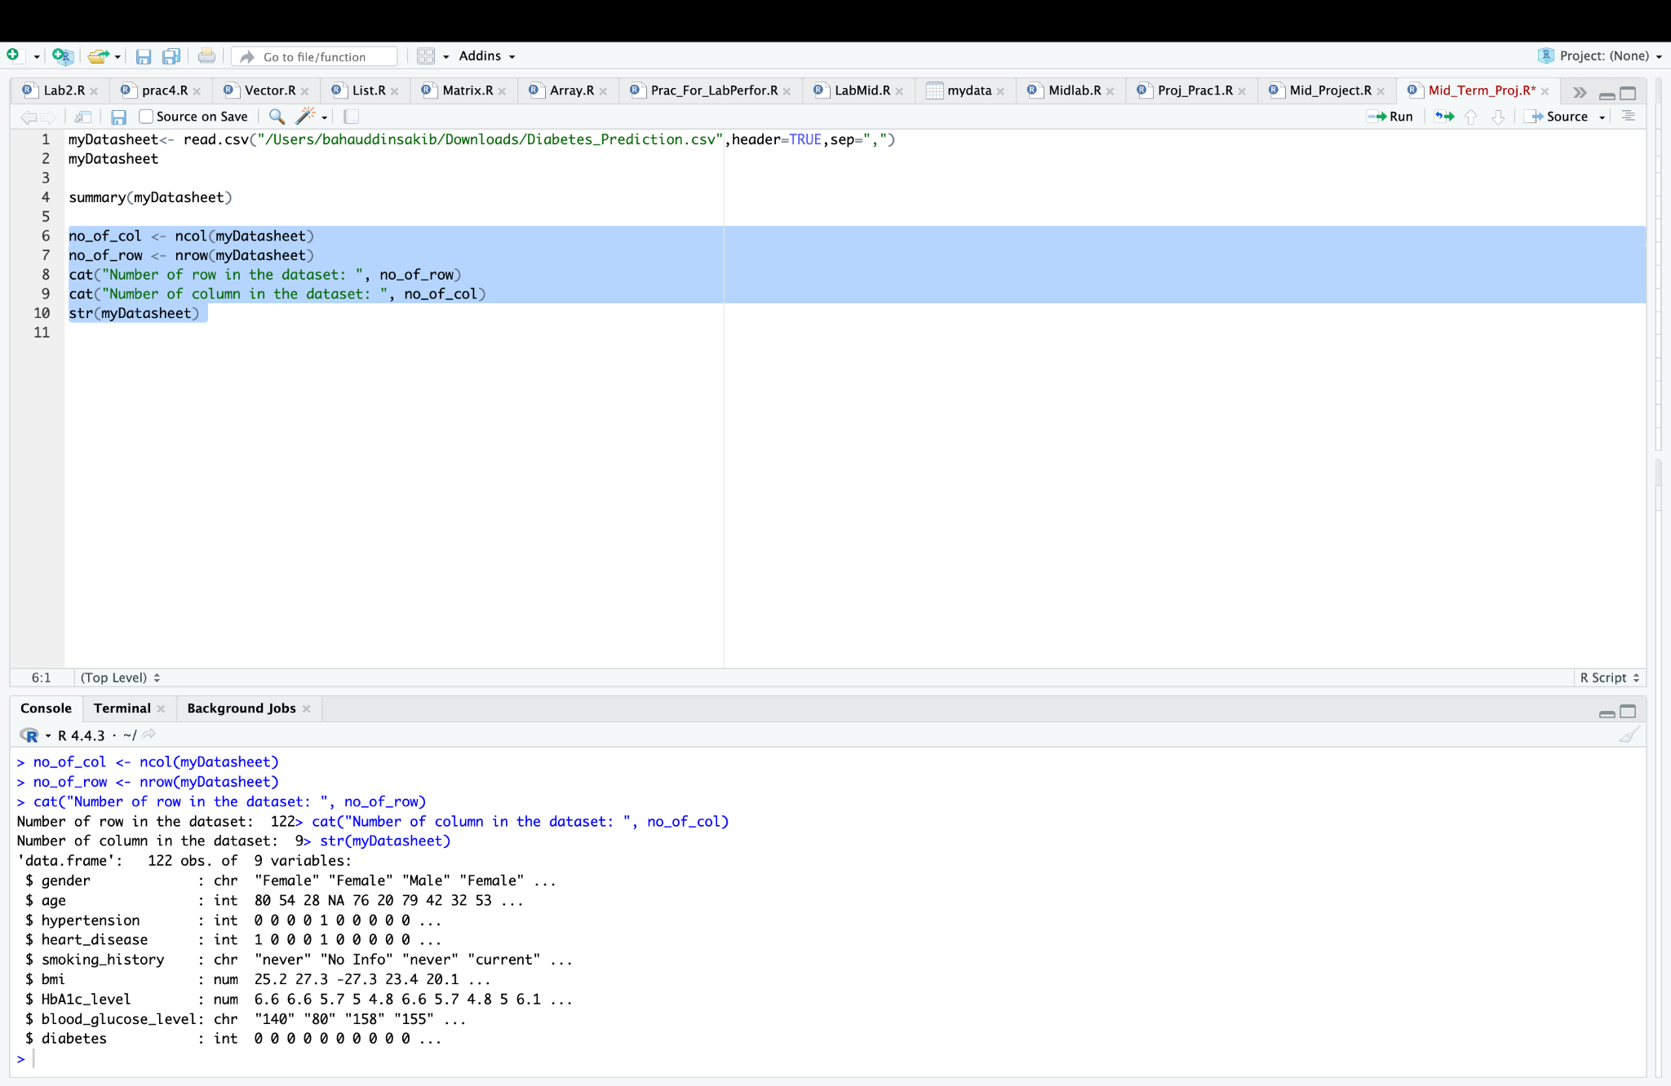

Fig: Number of row, column, attribute types and values of the data type

Here, we found that our dataset has 122 rows and 9 columns. There are 122 instances in the dataset. The age, hypertension, heart_disease, and diabetes attributes are integers. The bmi and HbAc_level attributes are in numerical form. The gender, smoking_history and blood_glucose_level attributes are character.

Now, let’s check the missing values from the dataset.

**Missing value check:**

Total missing value of the dataset:

***Code:***

sum(is.na(myDatasheet))

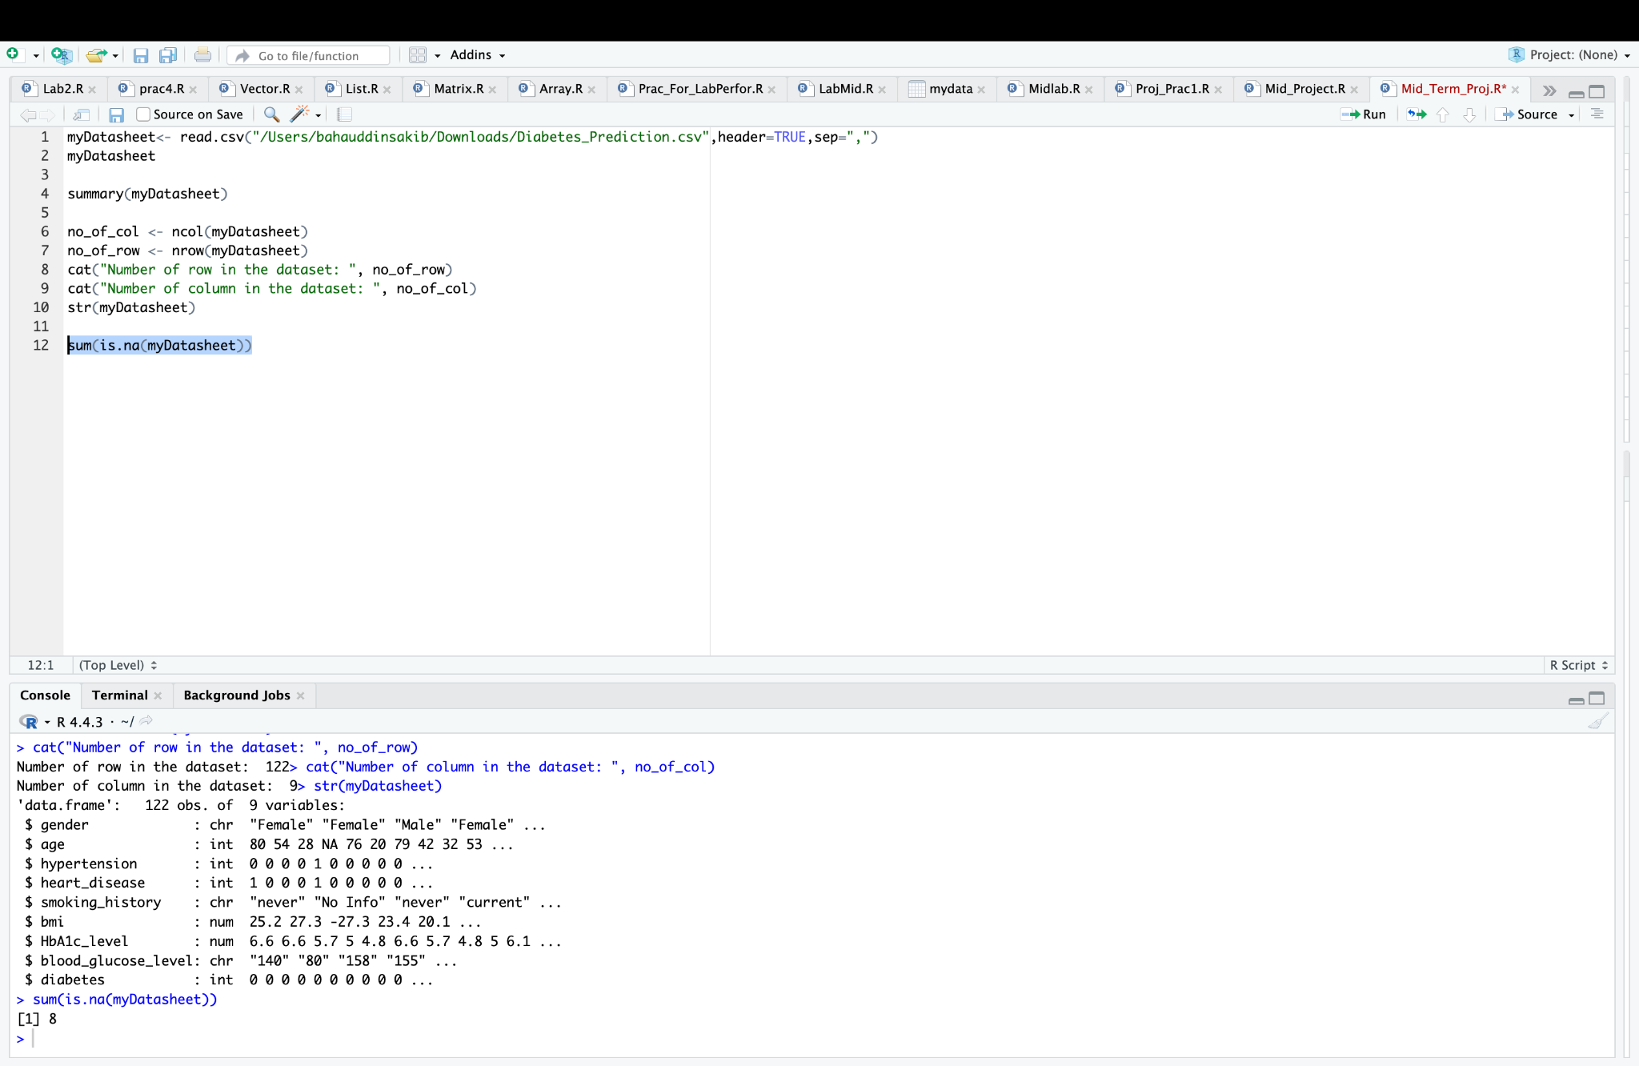

Fig: Total number of missing values

In total 8 missing values were found in the dataset.

Now, let’s the missing value column wise.

**Missing value in column:**

**CODE:**

colSums(is.na(myDatasheet))

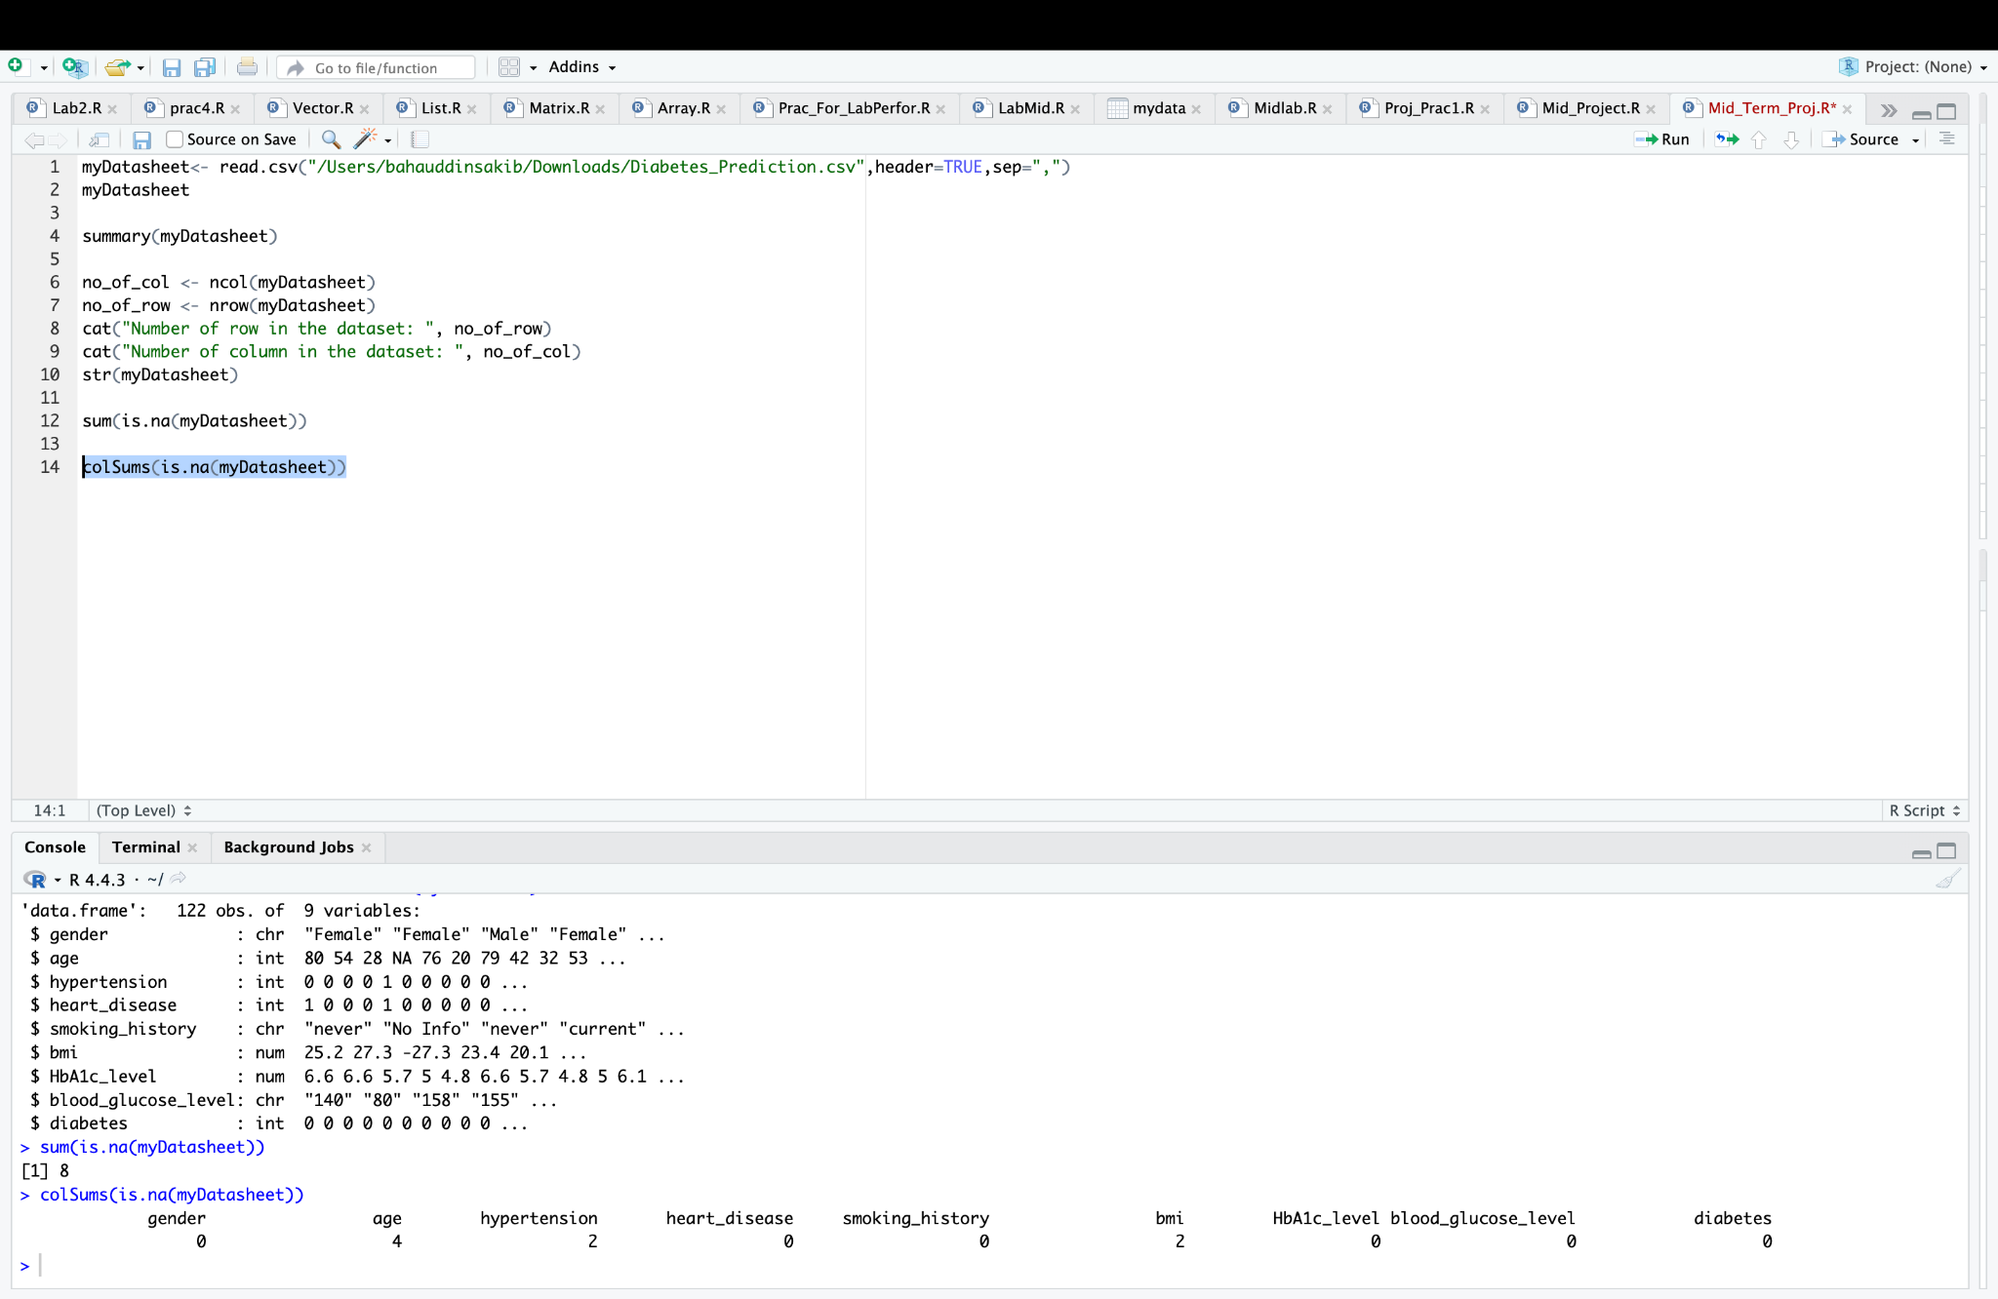

Fig: Number of missing values of column

In the age column there are 4 missing values. In hypertension and bmi there are 2 missing values individually. Total of 8 missing values in those columns. We need to recover them while preprocessing the dataset.

Now, let’s see the missing values in the graph. To show them we needed to install the “ggplot2” and “naniar” library. “ggplot2” is a library used for data visualization and “naniar” is designed for handling and visualizing missing data.

***Missing value Library Code:***

install.packages("ggplot2")

library(ggplot2)

install.packages("naniar")

library(naniar)

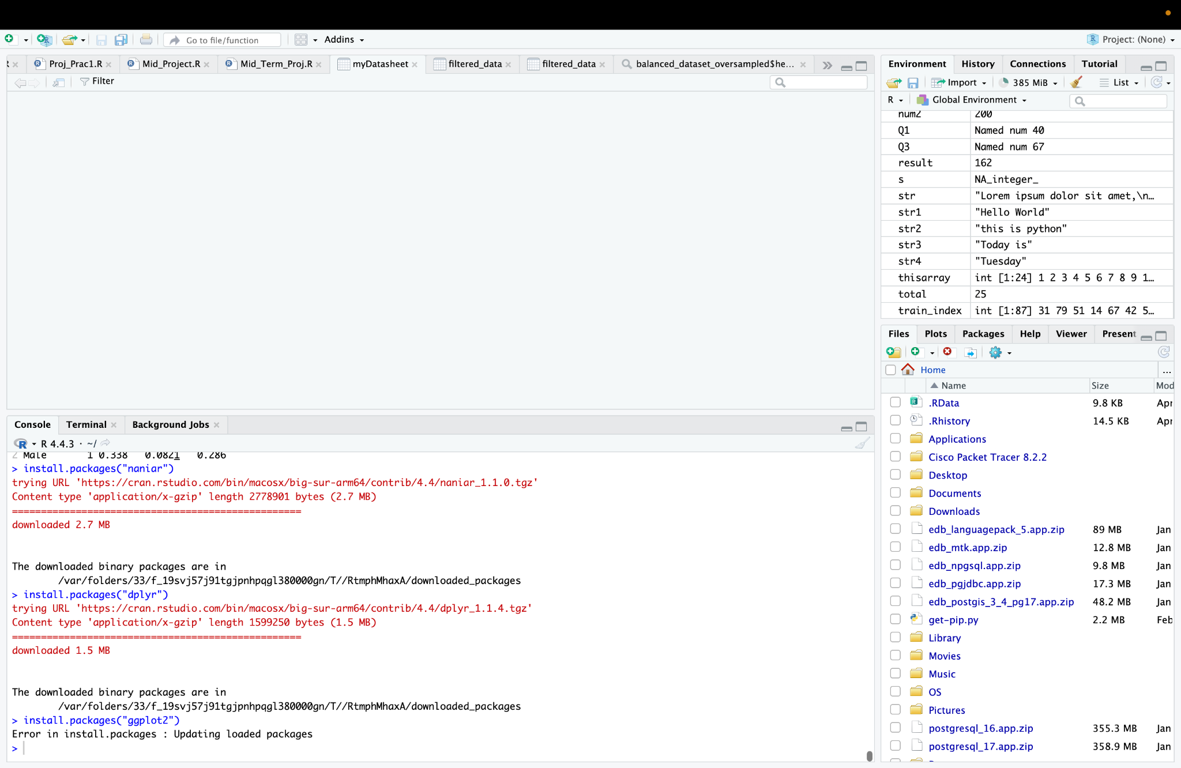

Fig: ggplot2 and naniar libraries

After installing those libraries, we can now visualise the missing values in the graph.

**Missing values in graph:**

**Code:**

gg_miss_upset(myDatasheet)

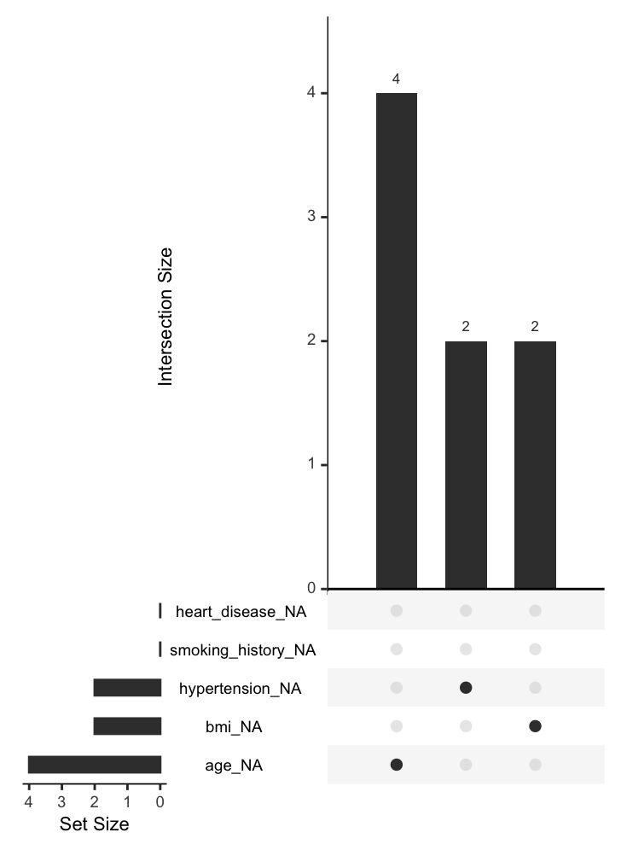

Fig: Missing values in graph

**Project Solution Design:**

The dataset contains missing values across several attributes, which must be handled carefully. We visualized these missing values using graphs and addressed them by either discarding incomplete instances or replacing them with the mean or most frequent values based on the attribute type. There might be outliers in specific attributes and they need to be handled using suitable methods to maintain data consistency. Invalid values, if present, need to be identified and corrected. Some attributes might need conversion to proper data types. We will need to normalize continuous attributes to bring them onto a common scale. Duplicate rows need to be removed to avoid redundancy, and filtering techniques might need to be applied to clean and refine the dataset. An imbalanced dataset was balanced using appropriate resampling methods. Then the cleaned dataset needs to split into training and testing sets for further analysis. Finally, we will need to compare the central tendencies (mean, median, mode) and spread (range, IQR, variance, standard deviation) of age across different groups of gender and hypertension to execute meaningful insights.

**Data Pre-processing:**

**Impute missing value age with Mean (Numerical Data):**

**Code:**

myDatasheet$age[is.na(myDatasheet$age)] <- mean(myDatasheet$age, na.rm = TRUE)

myDatasheet$blood_glucose_level <- gsub("[^0-9.]", "", myDatasheet$blood_glucose_level)

myDatasheet$blood_glucose_level <- as.numeric(myDatasheet$blood_glucose_level)

myDatasheet$blood_glucose_level[is.na(myDatasheet$blood_glucose_level)] <- mean(myDatasheet$blood_glucose_level, na.rm = TRUE)

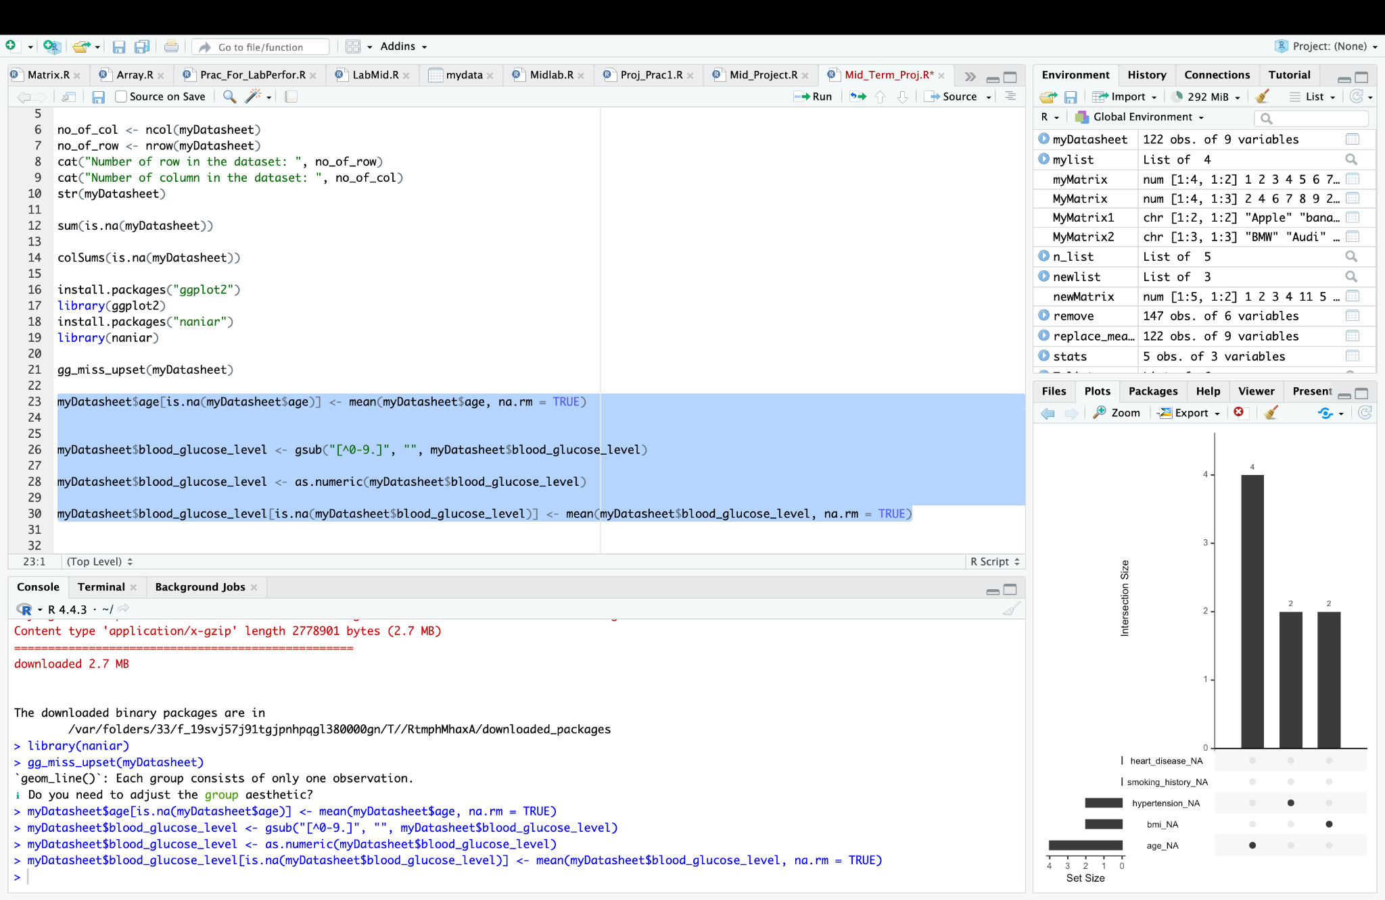

Fig: Impute missing value age with Mean

Firstly, we removed all the non-numeric characters from the age column. Then convert all the data into numeric. At last, impute all the missing value from the age column with the mean value.

**Impute Missing Using Mode (Categorical Data):**

get_mode <- function(v) {

uniqv <- unique(v)

uniqv[which.max(tabulate(match(v, uniqv)))]

}

myDatasheet$gender[is.na(myDatasheet$gender)] <- get_mode(myDatasheet$gender)

myDatasheet$smoking_history[is.na(myDatasheet$smoking_history)] <- get_mode(myDatasheet$smoking_history)

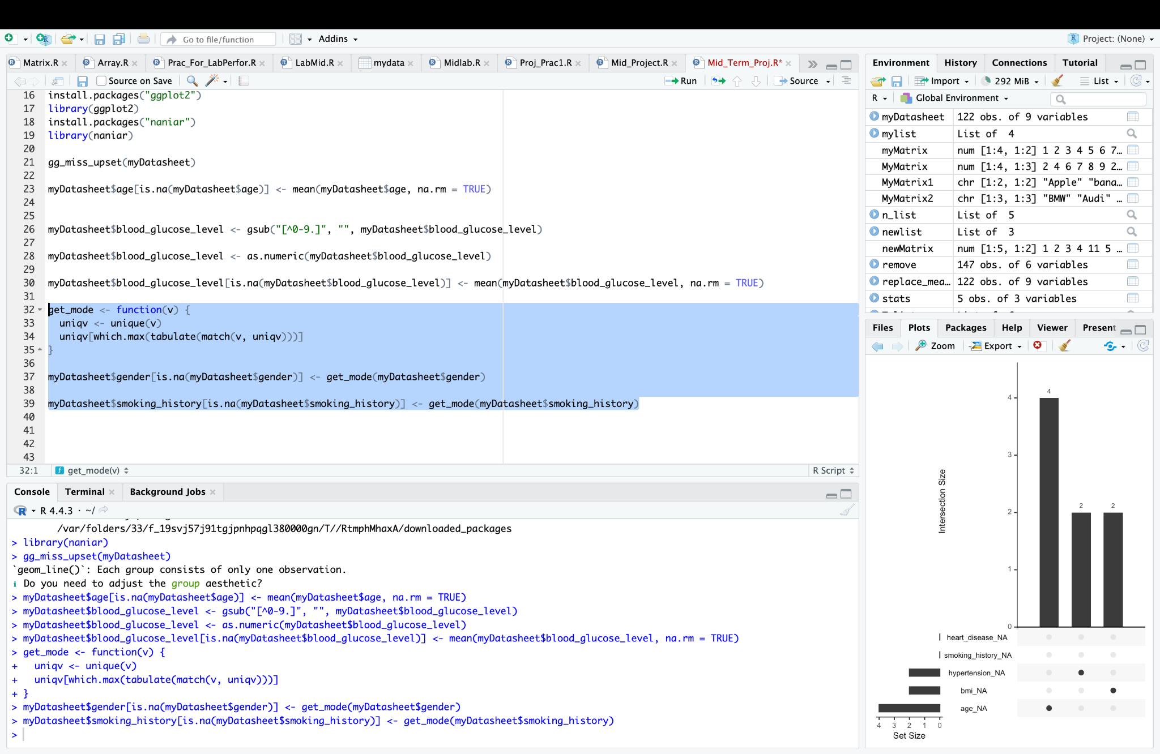

Fig: Impute Missing Using Mode

The function get_mode calculates the mode (most frequent value) of a given vector v by identifying the value that appears the most. It is then used to fill the missing values (NA) in the **gender** and **smoking_history** columns of the dataset myDatasheet with their respective mode values. This ensures that missing values in these categorical columns are replaced by the most frequent category, preserving the data's distribution.

**Clean gender values:**

myDatasheet$gender[myDatasheet$gender == "Femalee"] <- "Female"

myDatasheet$gender[myDatasheet$gender == "Malee"] <- "Male"

myDatasheet <- myDatasheet[myDatasheet$gender != "", ]

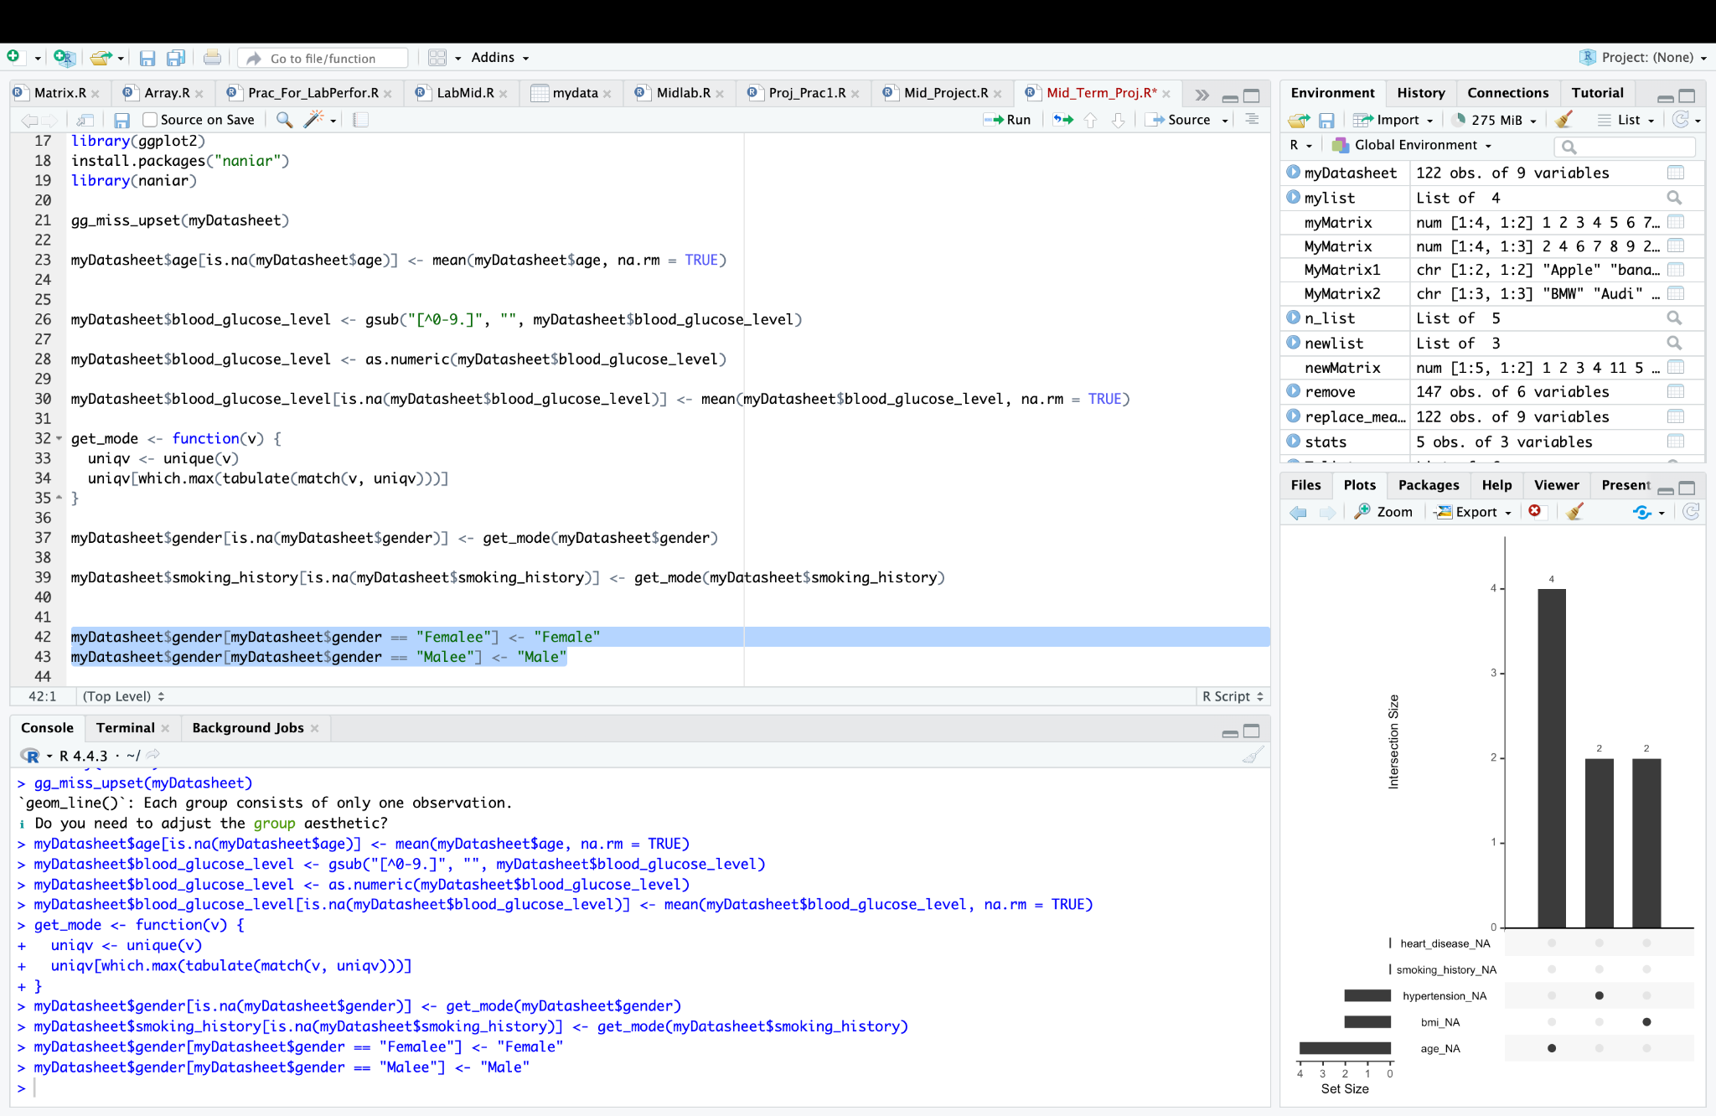

Fig: Changing incorrect value in gender column

This code replaces the incorrect values ("Femalee" and "Malee") in the **gender** column with the correct labels ("Female" and "Male"). It then removes any rows where the **gender** column is empty, ensuring data consistency and cleaning.

**Impute missing bmi:**

myDatasheet$bmi <- as.numeric(myDatasheet$bmi)

myDatasheet$bmi[myDatasheet$bmi <= 0] <- NA

myDatasheet$bmi[is.na(myDatasheet$bmi)] <- mean(myDatasheet$bmi, na.rm = TRUE)

After executing the code, the dataset was cleaned. Here is it:

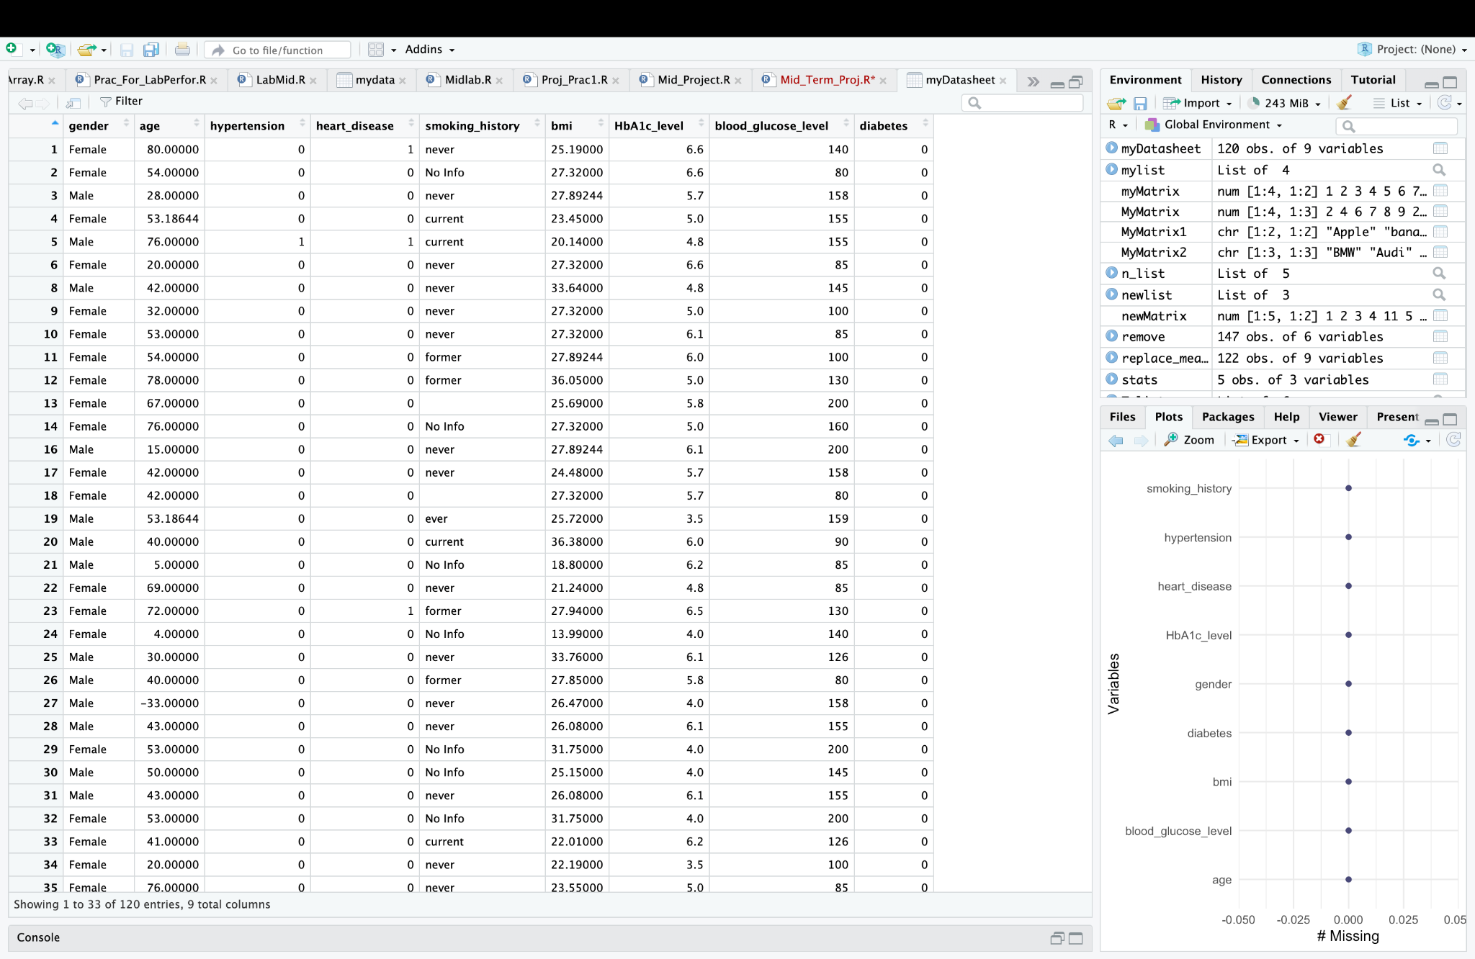

Fig: Clean dataset

Here we converted the **bmi** column to numeric and replaces invalid or non-positive values (less than or equal to 0) with NA. It then imputes the missing **bmi** values by replacing them with the mean of the non-missing **bmi** values in the dataset. And we got a cleaned datasheet.

**Missing value on a graph:**

After cleaning the missing values, we checked the missing value graph again.

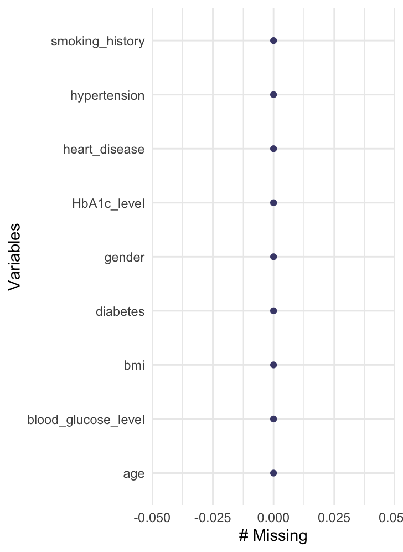

Fig: New missing value graph with 0 missing value

**Outlier:**

Q1 <- quantile(myDatasheet$age, 0.25)

Q3 <- quantile(myDatasheet$age, 0.75)

IQR <- Q3 - Q1

myDatasheet <- myDatasheet[!(myDatasheet$age < (Q1 - 1.5 * IQR) | myDatasheet$age > (Q3 + 1.5 * IQR)), ]

View(myDatasheet)

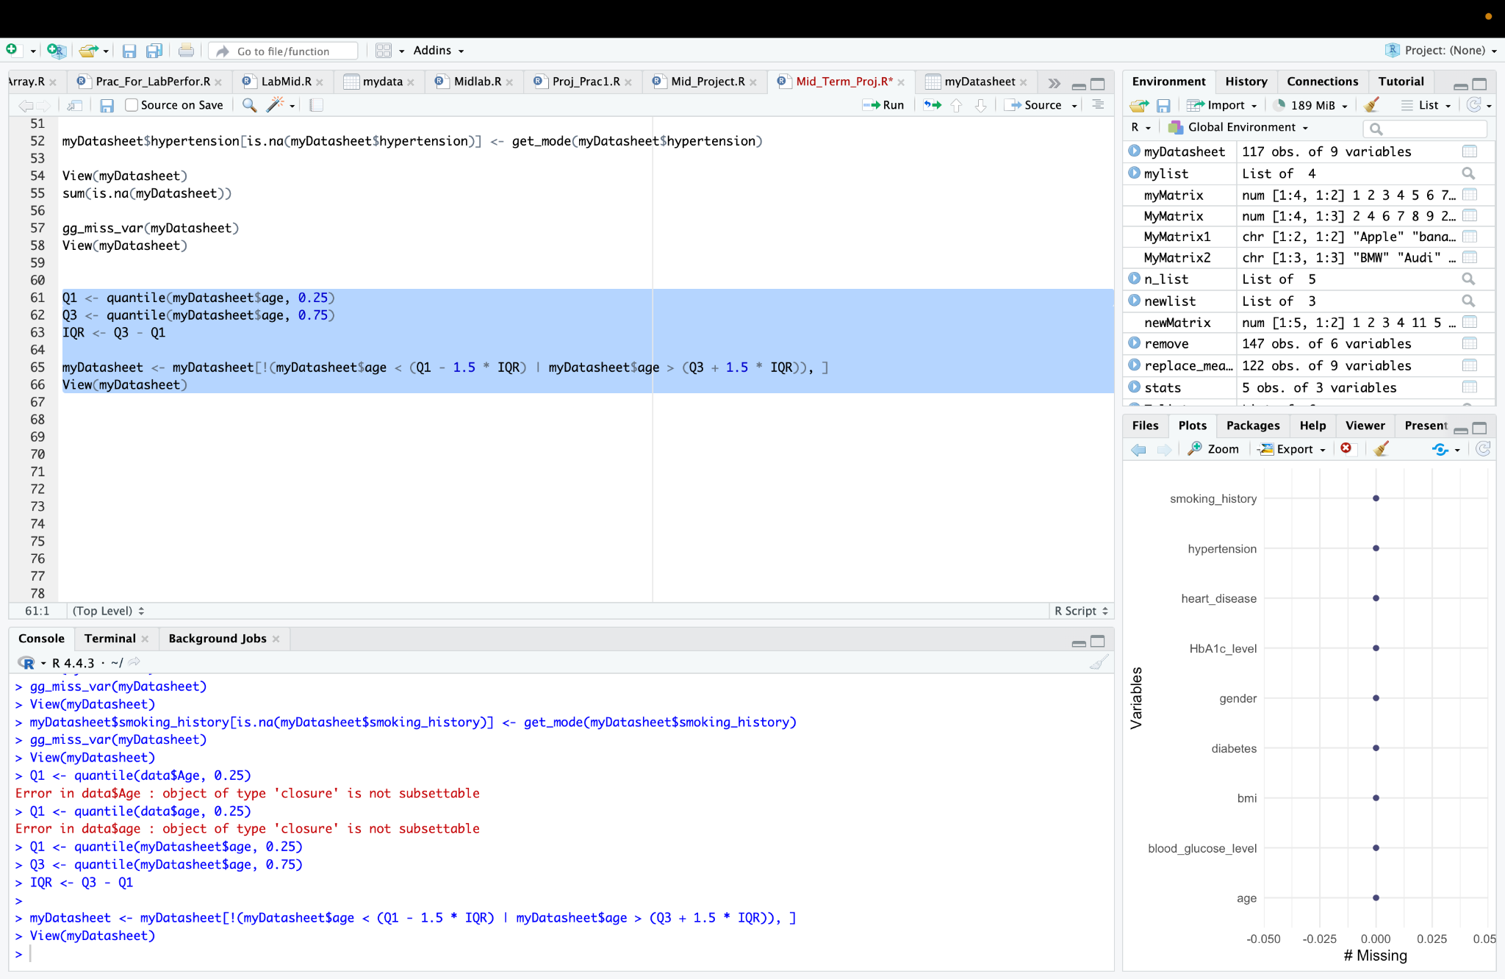Fig: Handled outliers from dataset

This code calculates the **Interquartile Range (IQR)** for the **age** column and filters out any values that are considered outliers, i.e., those that fall outside the range defined by Q1−1.5×IQRQ1 - 1.5 \times IQR and Q3+1.5×IQRQ3 + 1.5 \times IQR. The resulting dataset is then displayed using the View() function, showing the **age** values without outliers.

**Converting numerical to Categorical:**

myDatasheet$bmi <- cut(myDatasheet$bmi, breaks = c(0,18.5,24.9,Inf), labels = c("Low", "Medium", "High"))

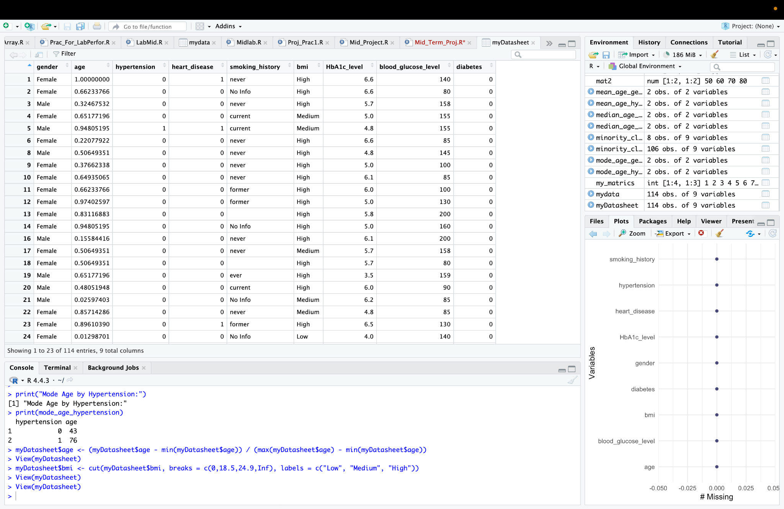

Fig:Conversion of numerical to Categorical

Here we converted the BMI column into categorical data from numerical. This code categorizes the bmi values into three groups based on standard BMI ranges: Low (for values less than 18.5), Medium (for values between 18.5 and 24.9), and High (for values greater than 24.9). The cut function is used to create these categories, and the bmi column is updated with these categorical labels.

**Normalization:**

**Code:**

myDatasheet$age <- (myDatasheet$age - min(myDatasheet$age)) / (max(myDatasheet$age) - min(myDatasheet$age))

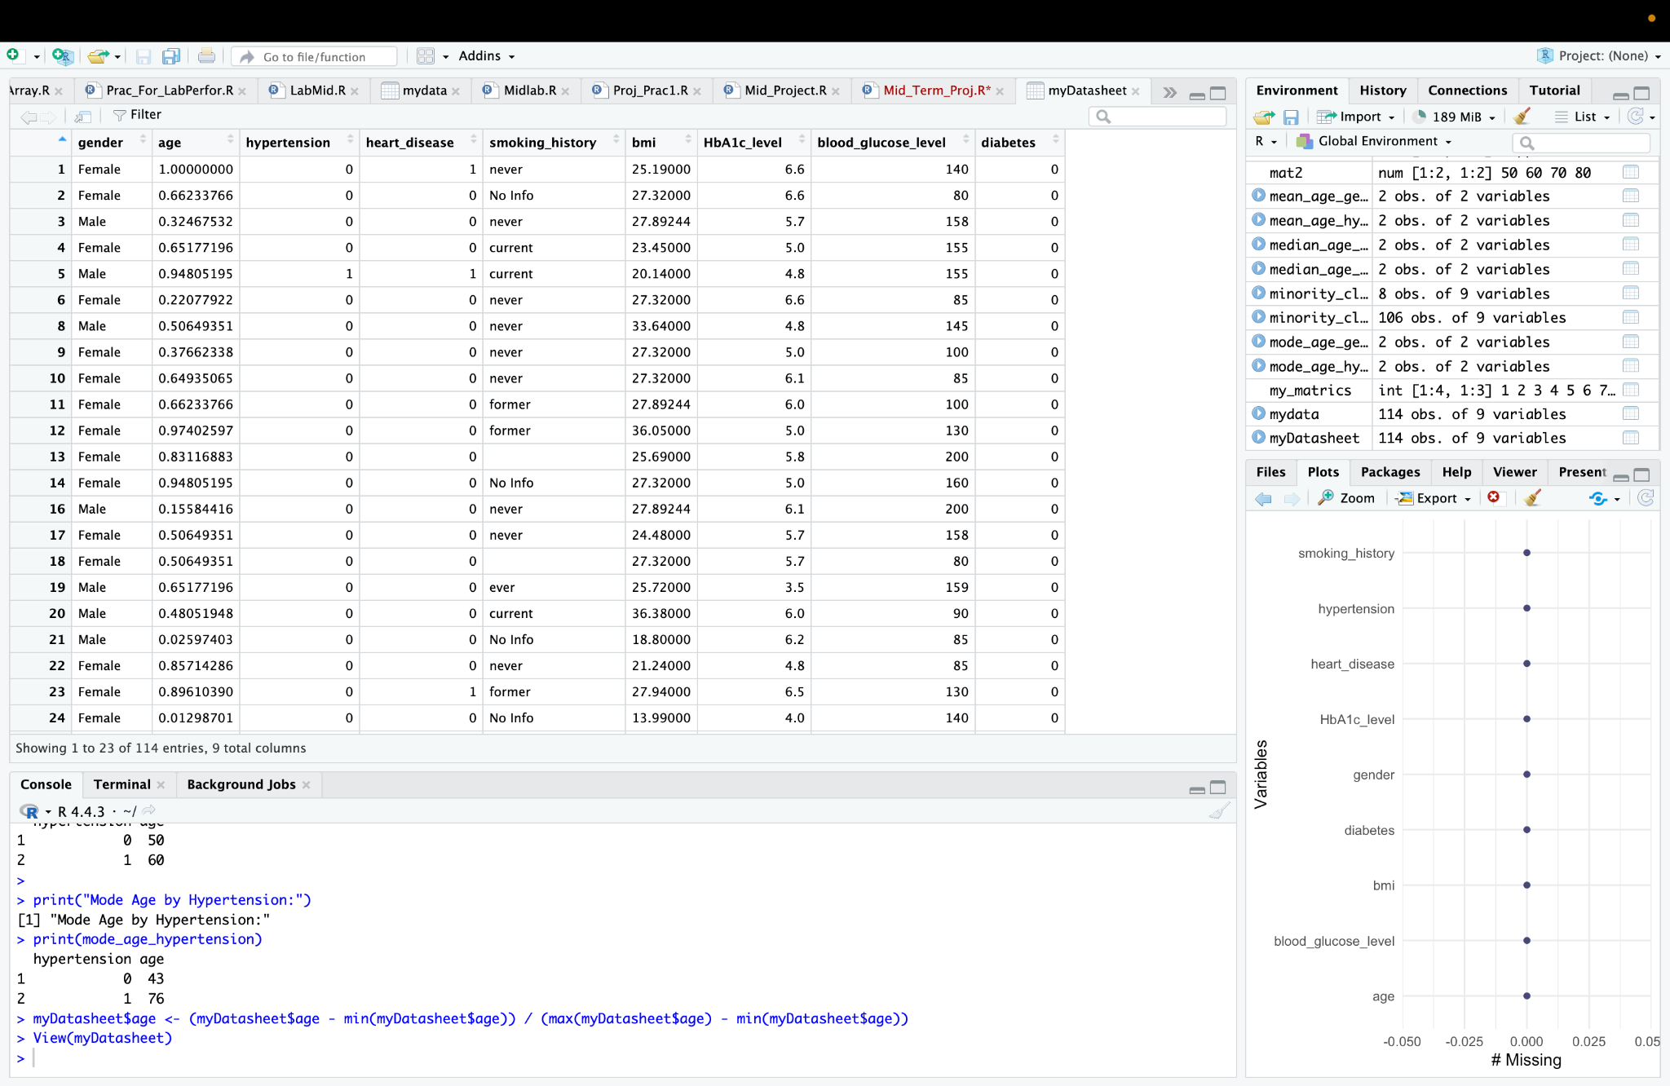

Fig: Normalization in Age column

Here we normalized the age column using Min-Max scaling, transforming the values to a range between 0 and 1. The formula subtracts the minimum age from each value and then divides by the range (the difference between the maximum and minimum age), ensuring that the normalized age values are on a consistent scale for further analysis or modeling.

**Remove duplicate:**

**Code:**

myDatasheet <- myDatasheet[!duplicated(myDatasheet),]

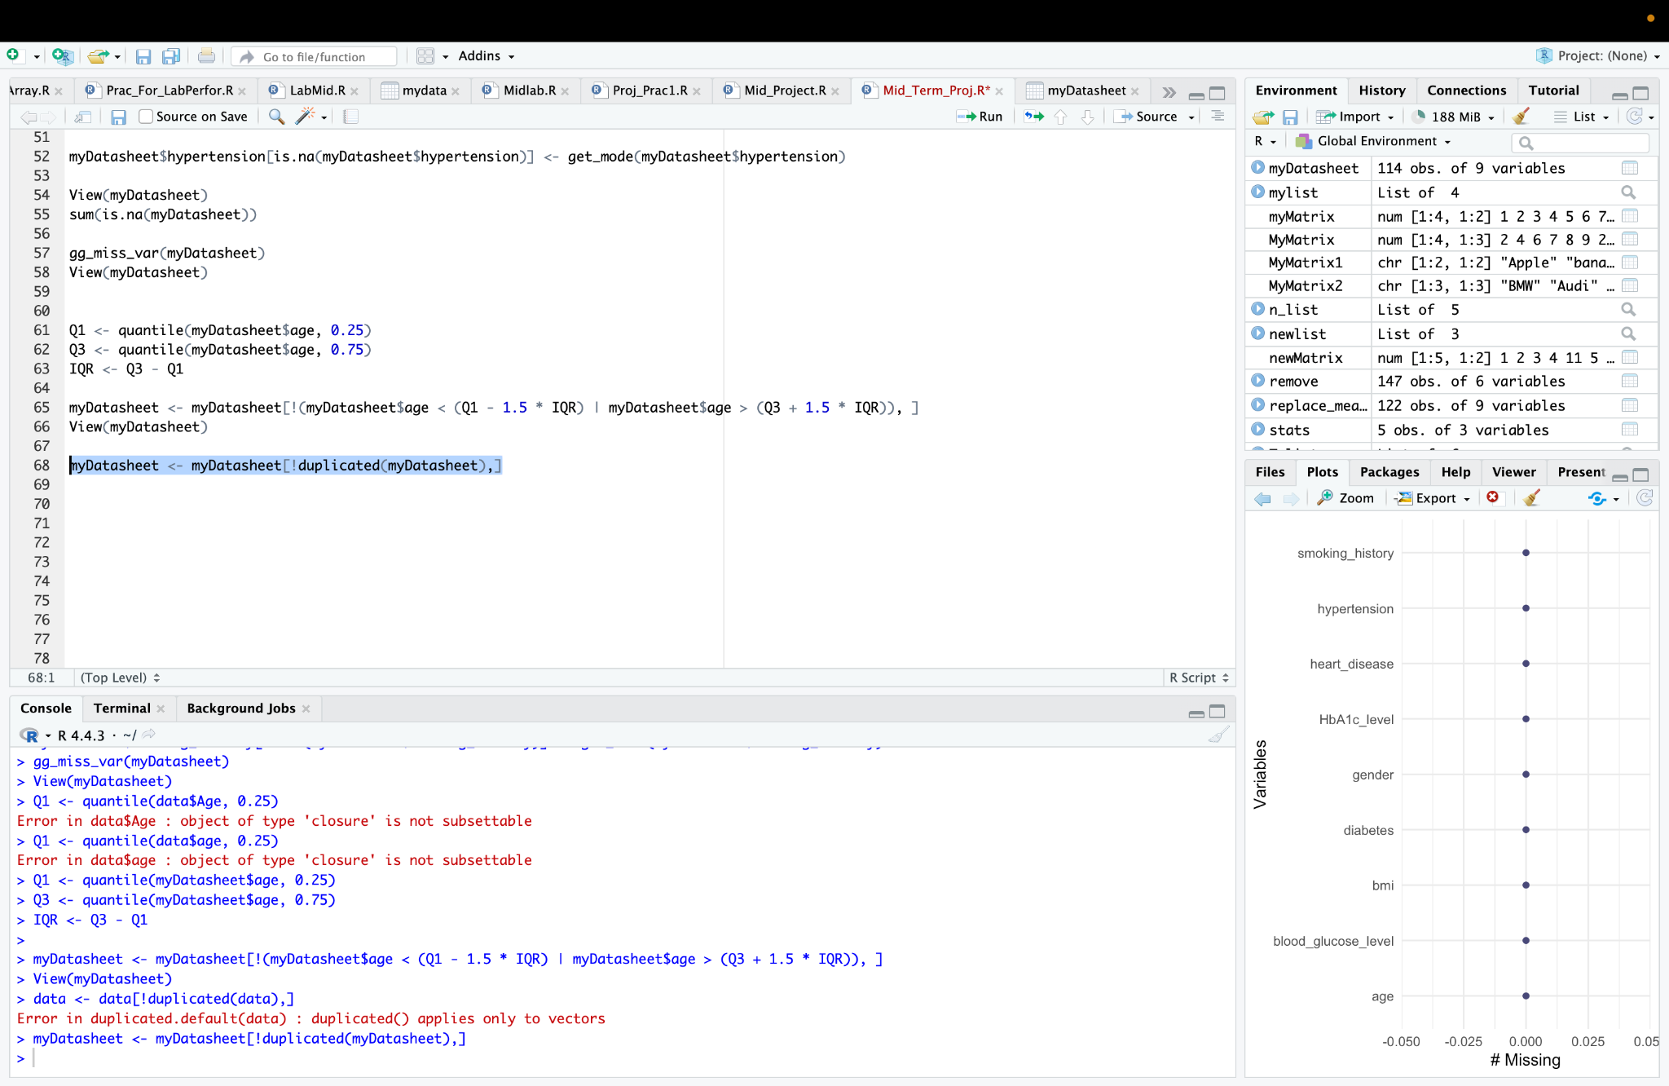

Fig: Removing all duplicate data from the datasheet

**Filtering package:**

To do the filter we needed to install the “dplyr” package. **“**dplyr**”** package - a cornerstone of the “tidyverse”, designed to make data manipulation elegant and readable. With” dplyr”, data can be filtered, arranged, summarized, group, and mutated.

***Code:***

install.packages("dplyr")

library(dplyr)

**Filtering 1:**

filtered_data <- myDatasheet[myDatasheet$age > 50, ]

View(filtered_data)

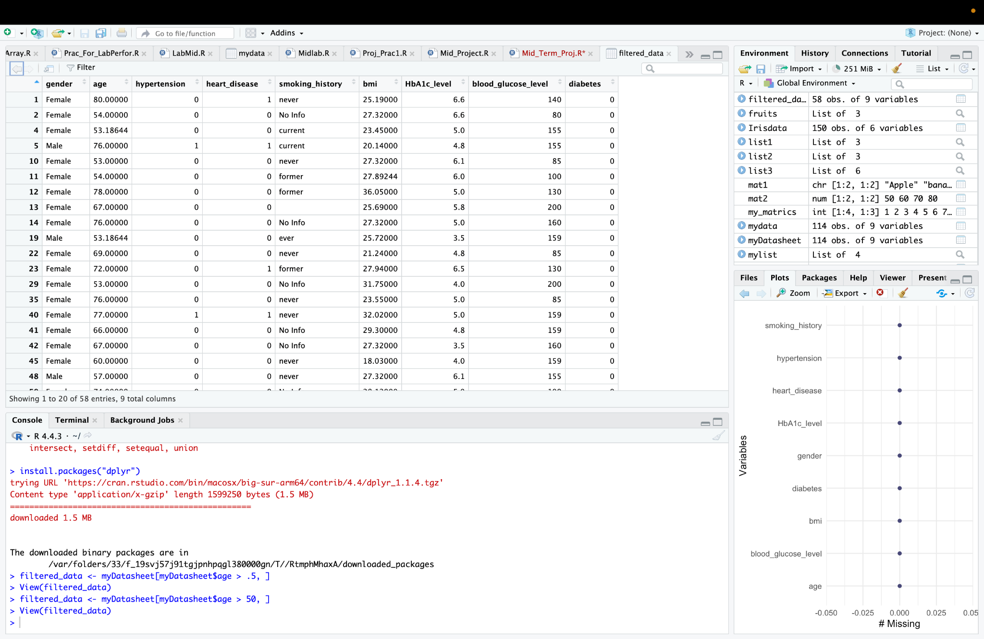

Fig: Installed dplyr and filter of age that are greater than 50

This code filters the dataset to include only the rows where the age is greater than 50, creating a new dataset called filtered_data. The View() function is then used to display this filtered dataset, allowing you to visually inspect the data of individuals aged above 50.

**Filtering 2:**

**Code:**

filtered_data <- myDatasheet %>% filter(age > 50 & gender == "Male")

View(filtered_data)

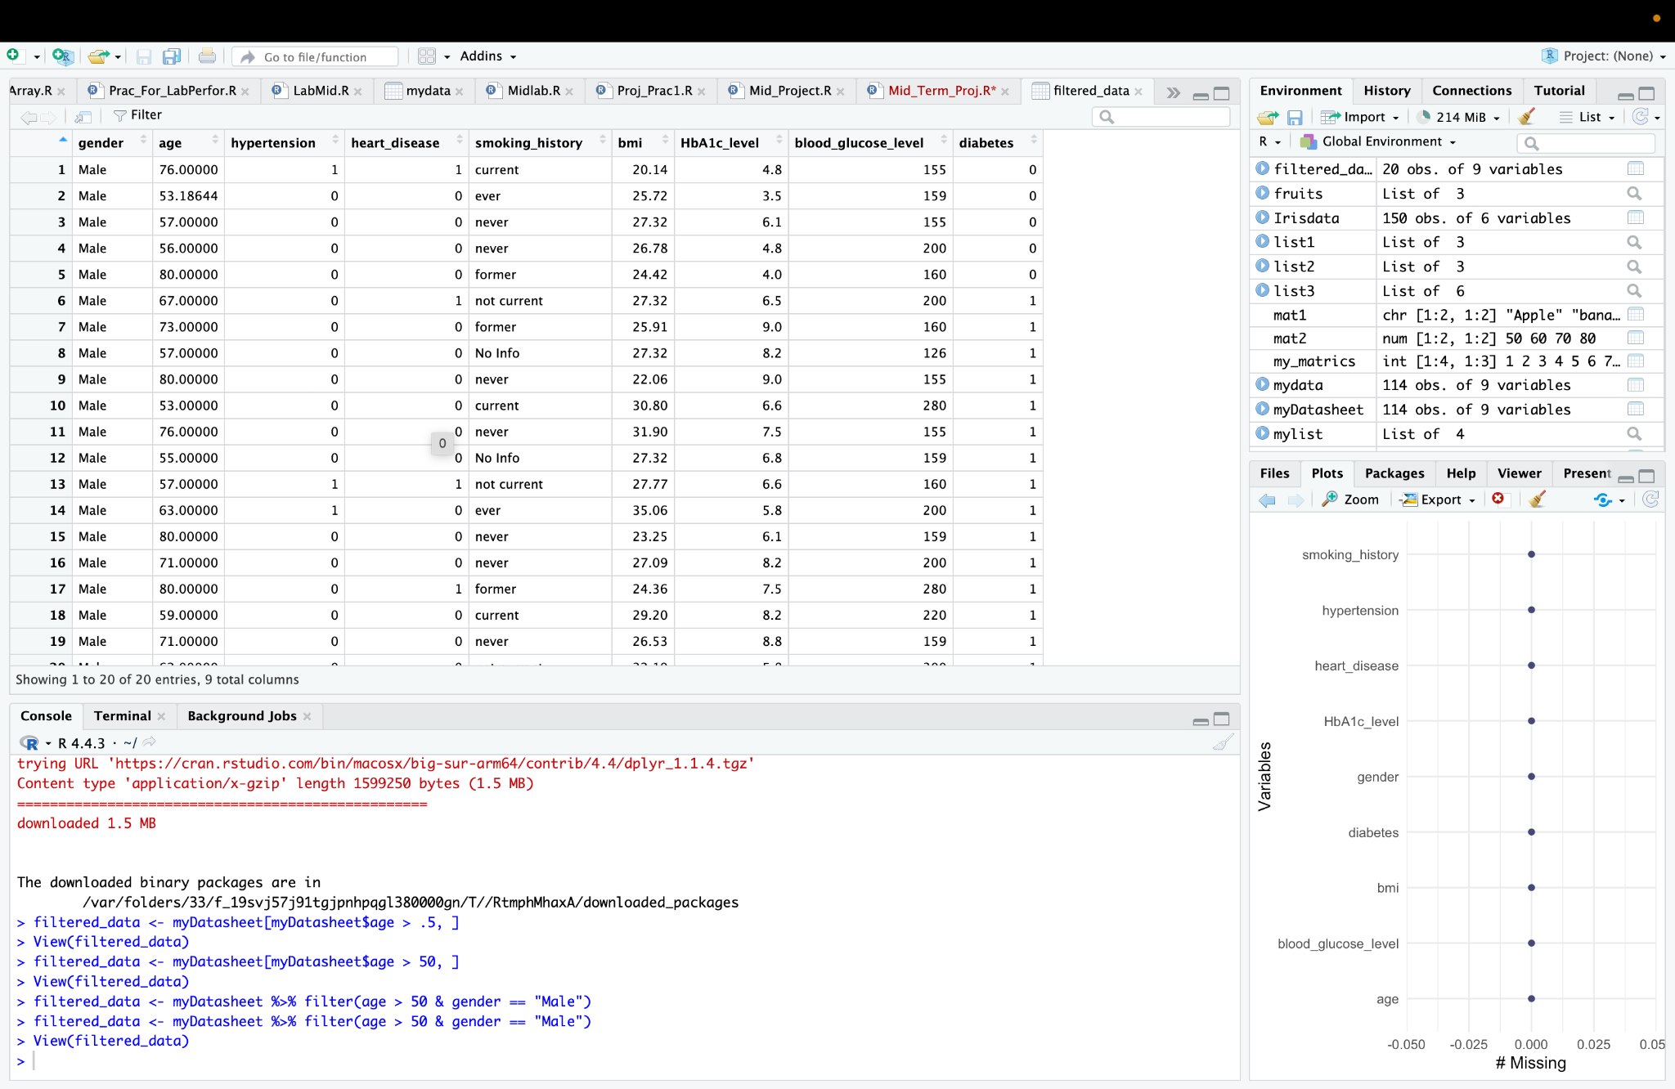

Fig: Filter of age that are greater than 50 and male

This code filters the dataset to include only the rows where the age is greater than 50 and the gender is "Male". The resulting filtered dataset is stored in the filtered_data variable, and the View() function is used to display it, allowing you to inspect the data of male individuals aged over 50.

**Detect invalid:**

**Code:**

invalid_age <- myDatasheet$age < 0

print(myDatasheet[invalid_age, ])

View(myDatasheet)

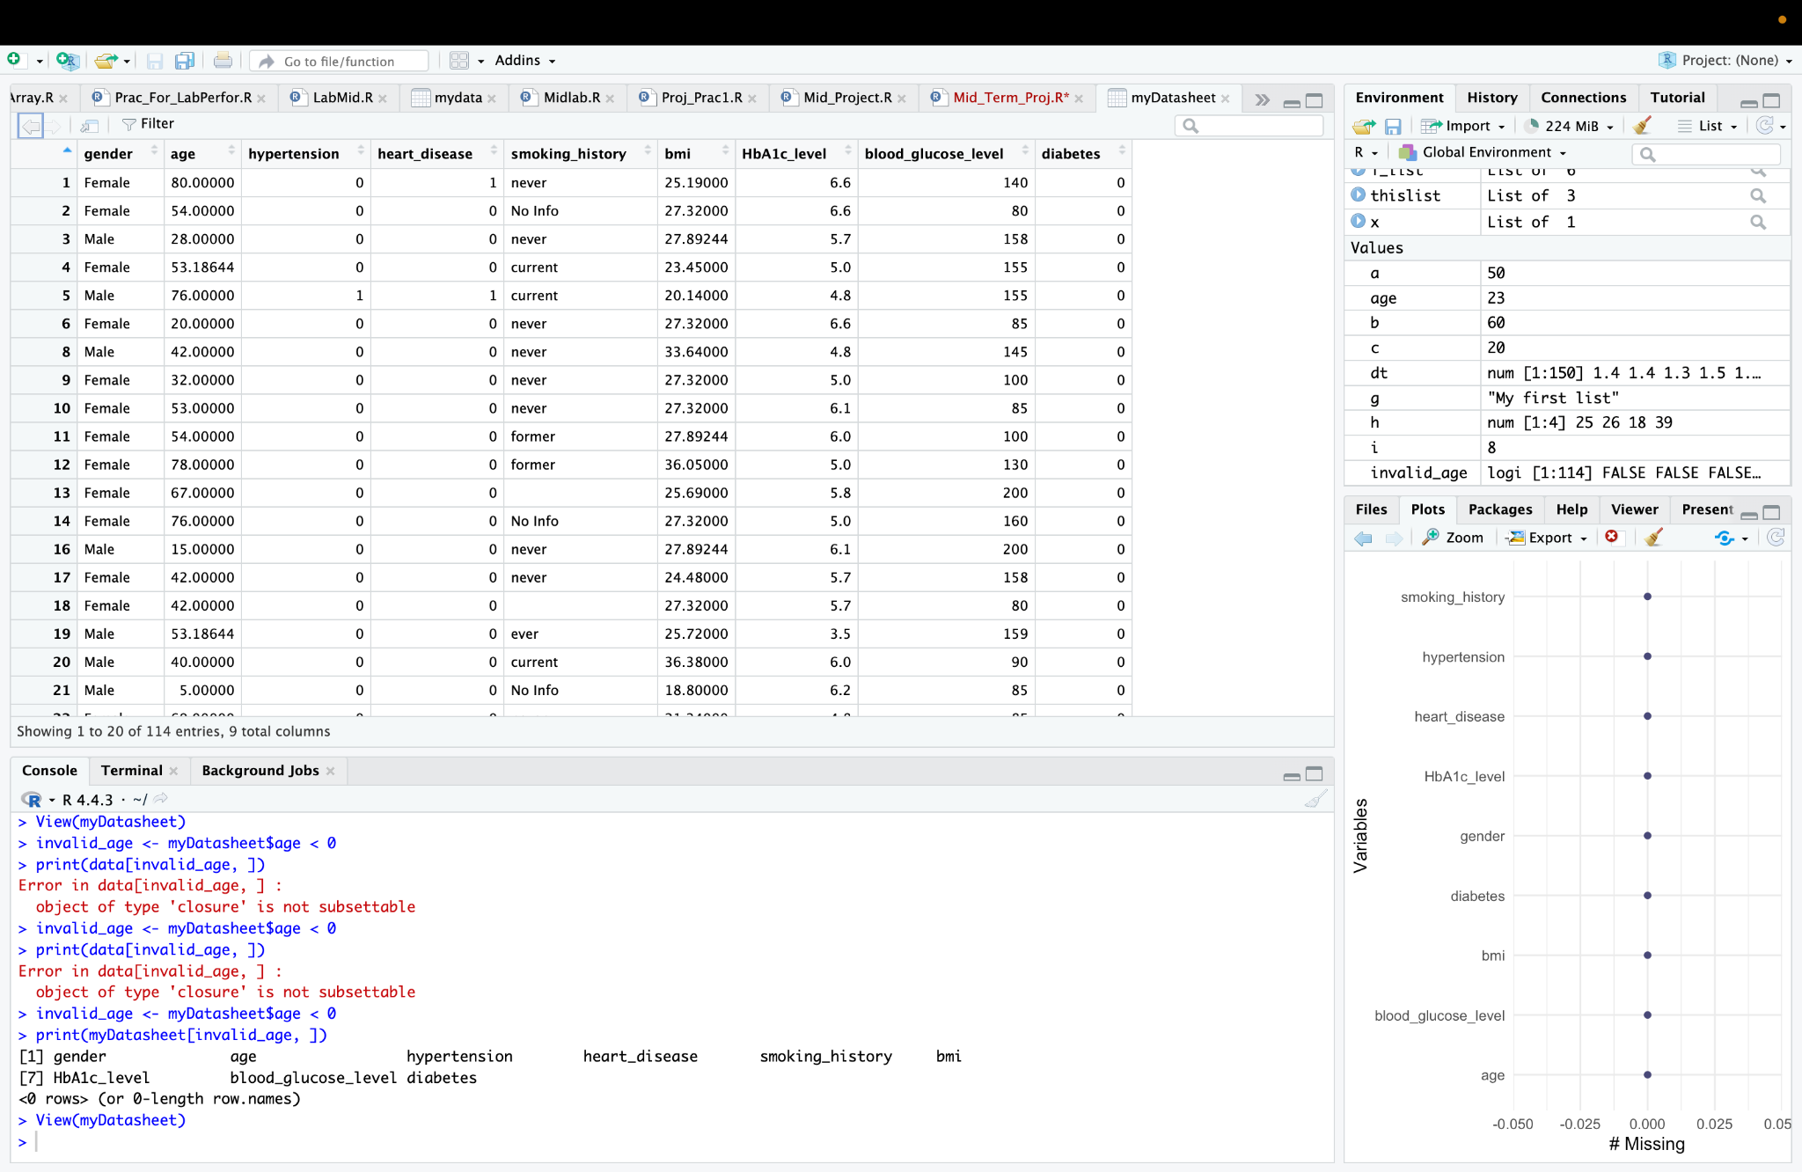

Fig: Detecting invalid data

This code identifies the rows where the age is less than 0 and stores the result in the invalid_age variable. It then prints these rows with invalid age values using print() and displays the entire myDatasheet dataset using the View() function to allow further inspection of the data.

**Check class distribution:**

**Code:**

table(myDatasheet$heart_disease)

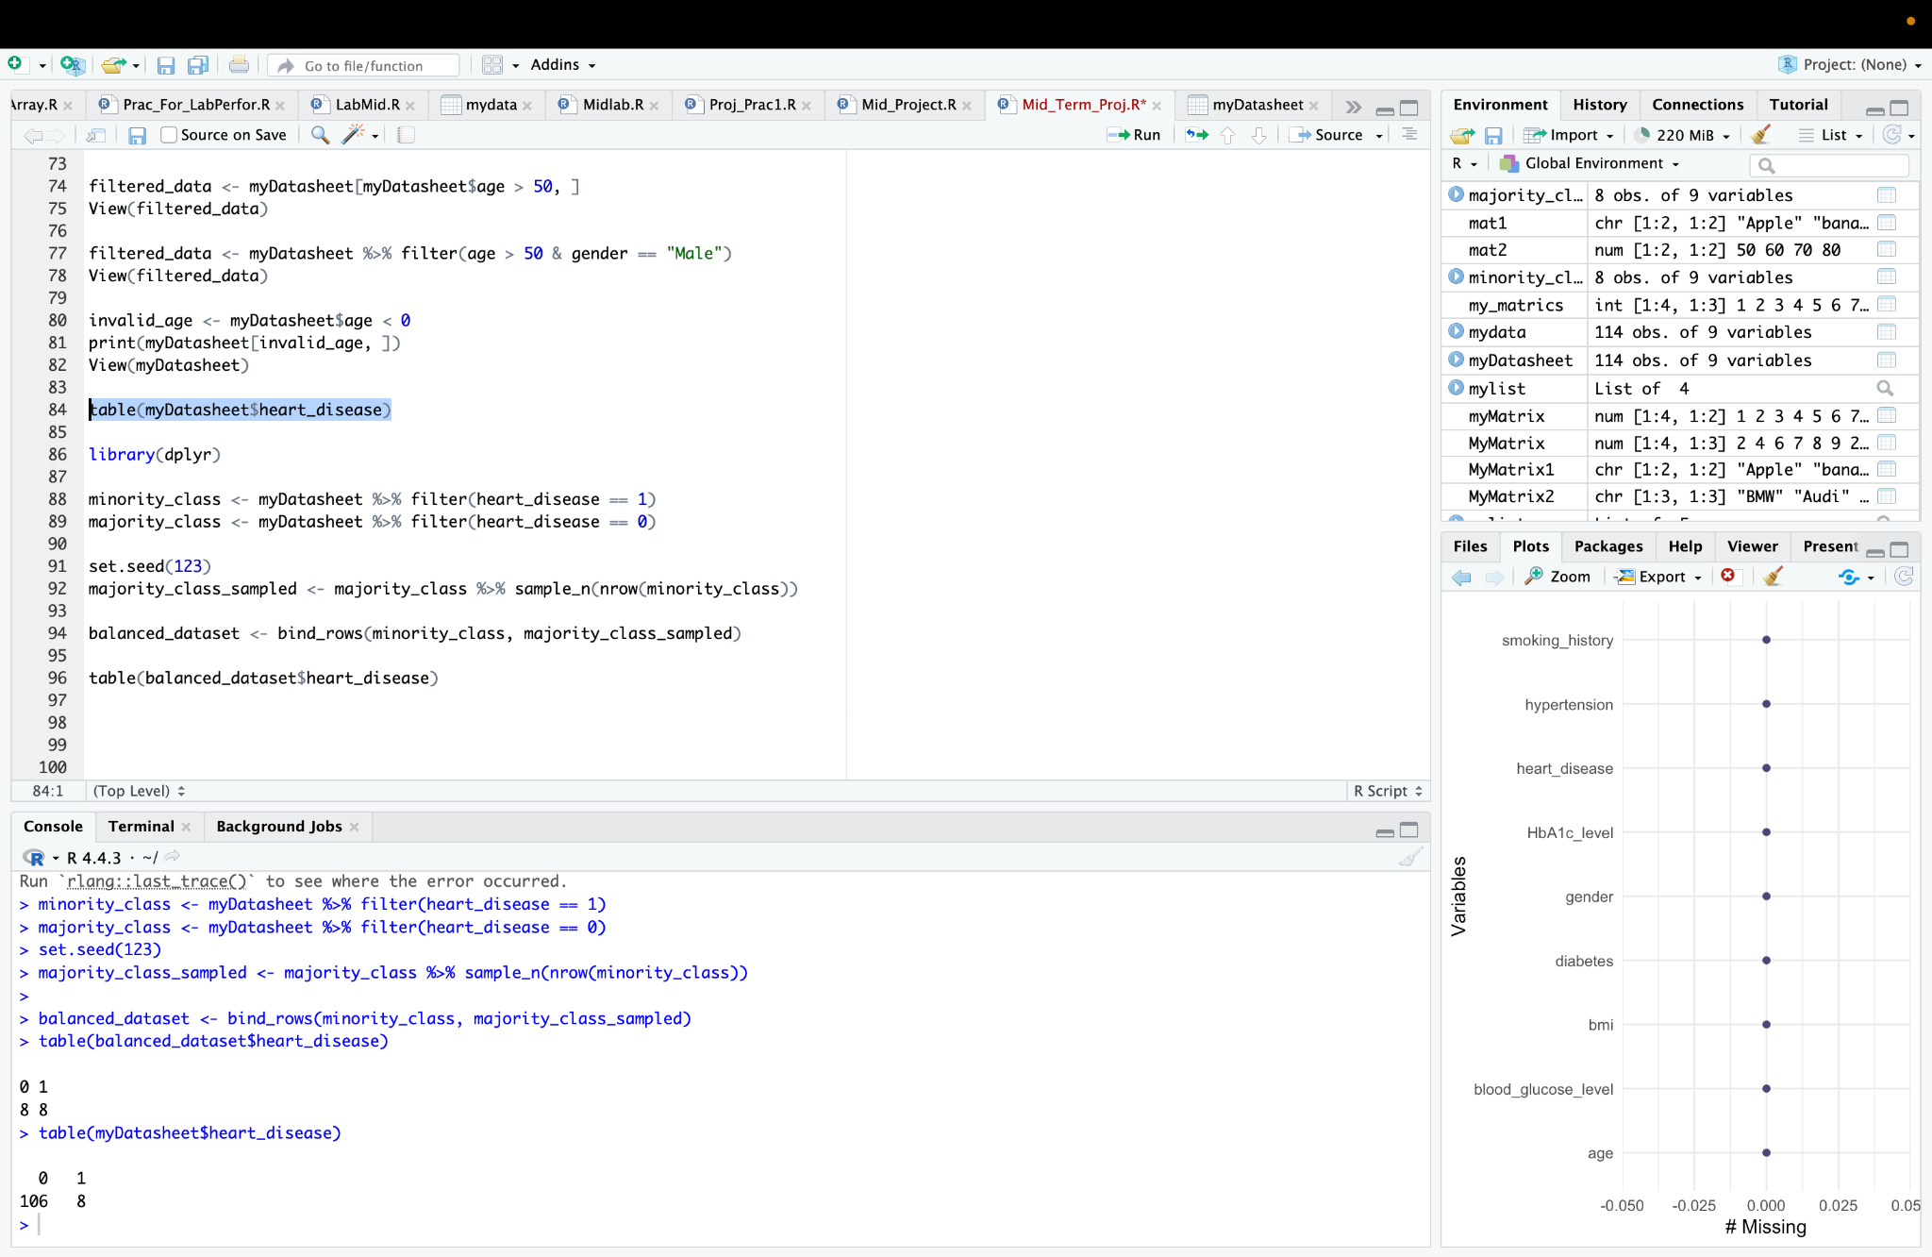

Fig: Checking class distribution

Here,

0 means people without heart disease

1 means people with heart disease

**Balancing datasheet:**

**Code:**

minority_class <- myDatasheet %>% filter(heart_disease == 1)

majority_class <- myDatasheet %>% filter(heart_disease == 0)

set.seed(123)

majority_class_sampled <- majority_class %>% sample_n(nrow(minority_class))

balanced_dataset <- bind_rows(minority_class, majority_class_sampled)

table(balanced_dataset$heart_disease)

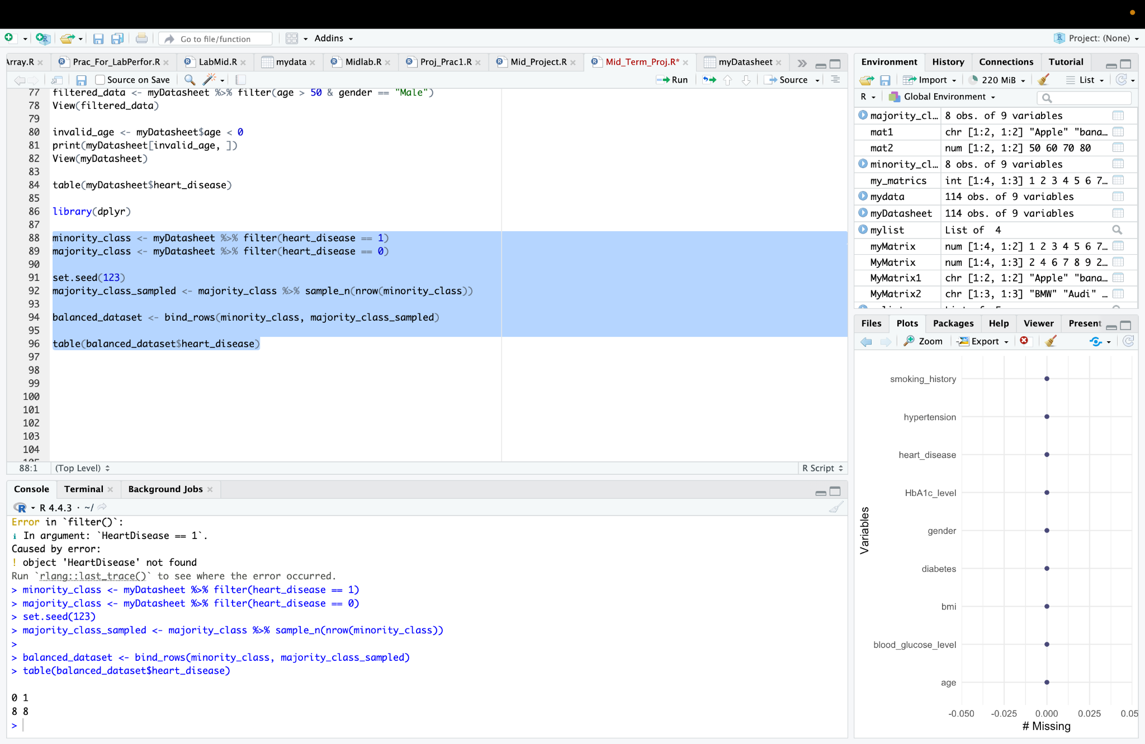

Fig: Balancing the datasheet based on hear disease column

This code performs undersampling to handle class imbalance in the heart_disease column. It separates the dataset into two groups: the minority_class (where heart_disease equals 1) and the majority_class (where heart_disease equals 0). The majority class is then randomly sampled to match the number of instances in the minority class using sample_n(). Afterward, the minority_class and the sampled majority_class are combined into a new dataset called balanced_dataset. Finally, it displays the count of each class in the heart_disease column to confirm the dataset is balanced.

**Balancing datasheet:**

**Code:**

n_majority <- nrow(majority_class)

n_minority <- nrow(minority_class)

if(n_majority >= n_minority) {

majority_class_sampled <- majority_class %>% sample_n(n_minority)

} else {

print("The majority class is smaller than the minority class.")

}

minority_class_oversampled <- minority_class %>% sample_n(nrow(majority_class), replace = TRUE)

balanced_dataset_oversampled <- bind_rows(minority_class_oversampled, majority_class)

table(balanced_dataset_oversampled$heart_disease)

View(balanced_dataset_oversampled$heart_disease)

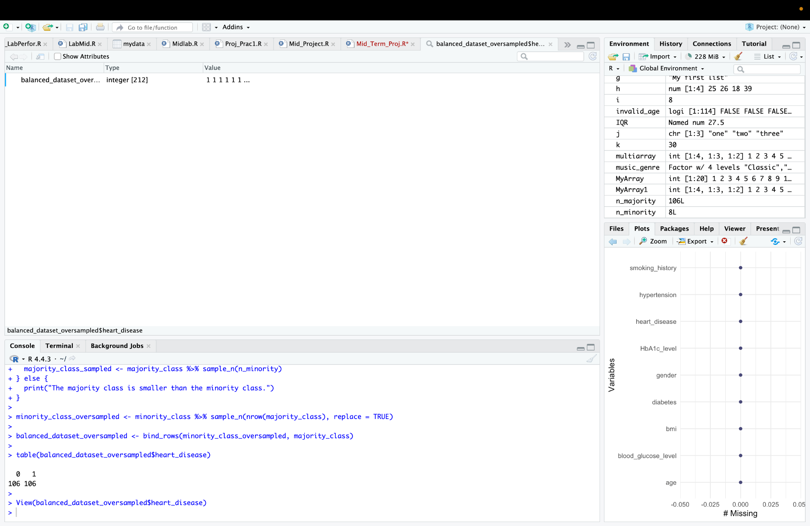

Fig: Oversampling for balanced dataset

This code handles class imbalance by undersampling the majority class (if it is larger than the minority class) and oversampling the minority class to match the size of the majority class. The oversampled dataset is then combined into a new balanced_dataset_oversampled. The class distribution is displayed with table() and the dataset is shown using View() to confirm the balance.

**Split dataset for Training and Testing:**

**Code:**

set.seed(123)

train_index <- sample(1:nrow(myDatasheet), 0.8 * nrow(myDatasheet))

train_data <- myDatasheet[train_index, ]

test_data <- myDatasheet[-train_index, ]

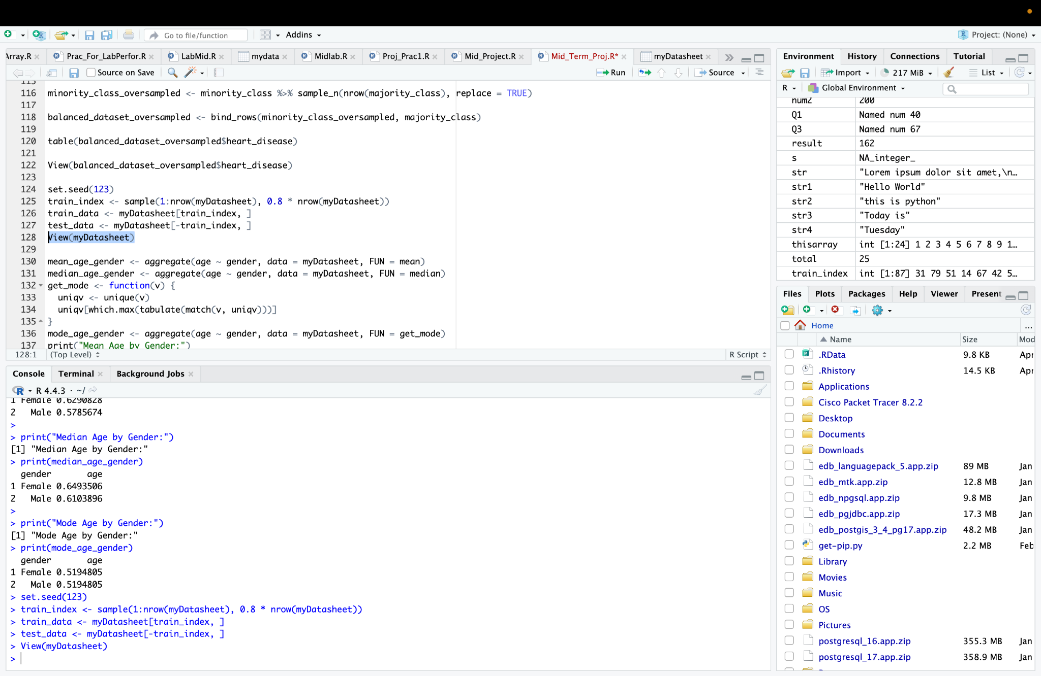

Fig: Splitting the data set

Here we splited the myDatasheet dataset into training and testing sets. It uses a random sampling method with a set.seed(123) for reproducibility, selecting 80% of the rows for the train_data and the remaining 20% for the test_data. The train_index holds the randomly selected indices for the training set, and the test set is derived by excluding those indices from the original dataset.

**Compare the central tendencies age across gender:**

**Code:**

mean_age_gender <- aggregate(age ~ gender, data = myDatasheet, FUN = mean)

median_age_gender <- aggregate(age ~ gender, data = myDatasheet, FUN = median)

get_mode <- function(v) {

uniqv <- unique(v)

uniqv[which.max(tabulate(match(v, uniqv)))]

}

mode_age_gender <- aggregate(age ~ gender, data = myDatasheet, FUN = get_mode)

print("Mean Age by Gender:")

print(mean_age_gender)

print("Median Age by Gender:")

print(median_age_gender)

print("Mode Age by Gender:")

print(mode_age_gender)

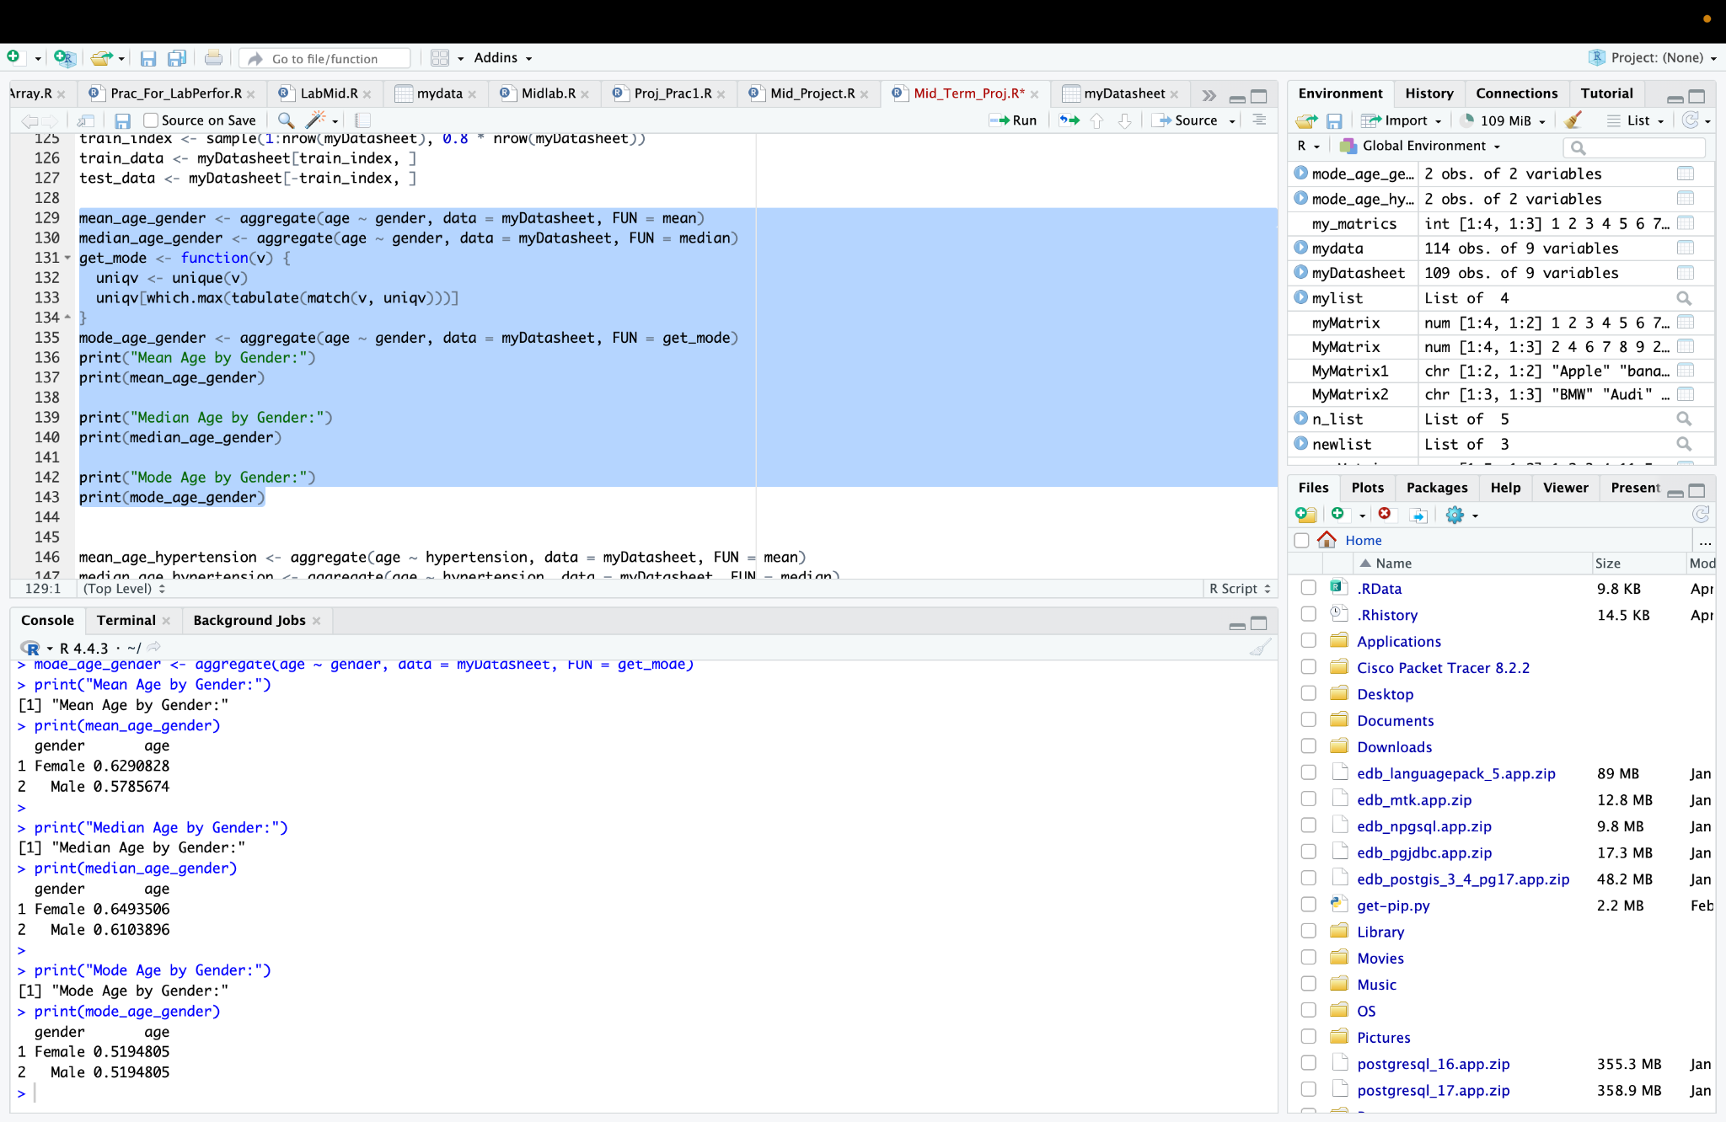

Fig:Compare the central tendencies age across gender

Here we calculate and prints the mean, median, and mode of age grouped by gender. It uses the aggregate () function to compute the mean and median values for each gender, and a custom function get_mode to calculate the mode of age by gender. The results for each statistic are then printed, displaying the mean, median, and mode of age for both Male and Female groups.

**Compare the central tendencies across hypertension:**

**Code:**

mean_age_hypertension <- aggregate(age ~ hypertension, data = myDatasheet, FUN = mean)

median_age_hypertension <- aggregate(age ~ hypertension, data = myDatasheet, FUN = median)

mode_age_hypertension <- aggregate(age ~ hypertension, data = myDatasheet, FUN = get_mode)

print("Mean Age by Hypertension:")

print(mean_age_hypertension)

print("Median Age by Hypertension:")

print(median_age_hypertension)

print("Mode Age by Hypertension:")

print(mode_age_hypertension)

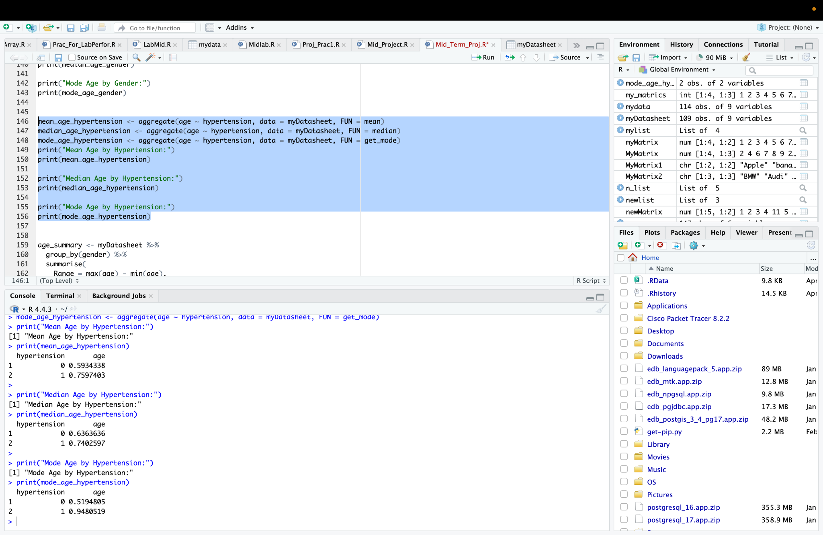

Fig: Compare the central tendencies age across hypertension

Here we calculate and prints the mean, median, and mode of age grouped by hypertension status. It uses the aggregate () function to compute the mean and median of age for individuals with and without hypertension. A custom function get_mode is used to calculate the mode of age within each hypertension group. The results for each of the statistics (mean, median, mode) are then printed for both groups, providing insights into the central tendency of age based on hypertension status.

**Compare the spread:**

**Code:**

age_summary <- myDatasheet %>%

group_by(gender) %>%

summarise(

Range = max(age) - min(age),

IQR = IQR(age),

Variance = var(age),

Std_Dev = sd(age)

)

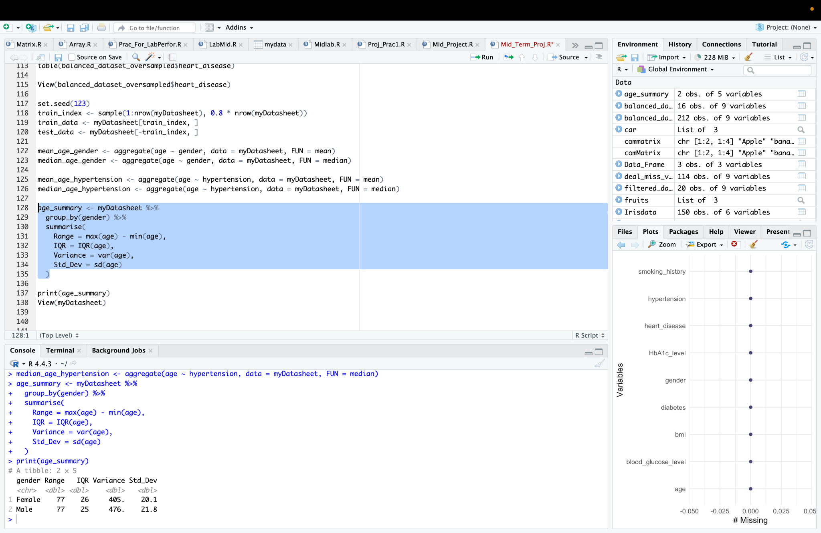

Fig: Compare the Spread (Range, IQR, Variance, Standard Deviation) of Age across different groups of Gender

Here we calculate summary statistics for the age attribute grouped by gender using the dplyr package. It computes the range (difference between maximum and minimum), Interquartile Range (IQR), variance, and standard deviation (Std_Dev) for age within each gender group. The summarise() function is used to generate these statistical measures, providing a detailed understanding of the spread and variability of age by gender.

**Code to export the dataset:**

**Code:**

write.csv(myDatasheet, "~/Desktop/My1/myDatasheet_export.csv", row.names = FALSE)

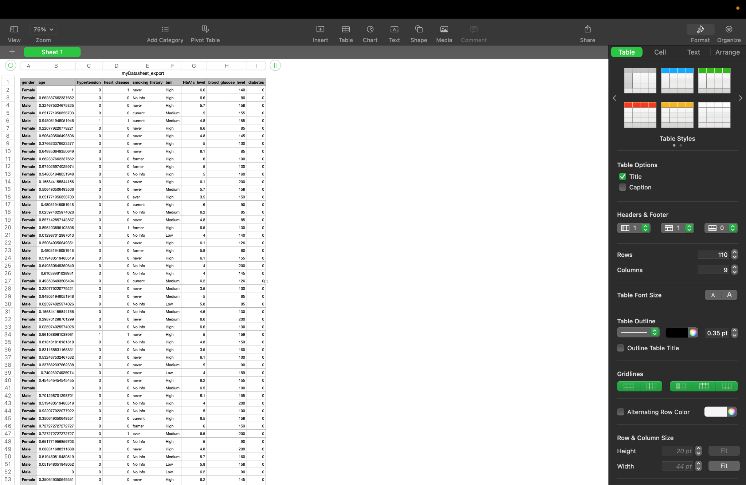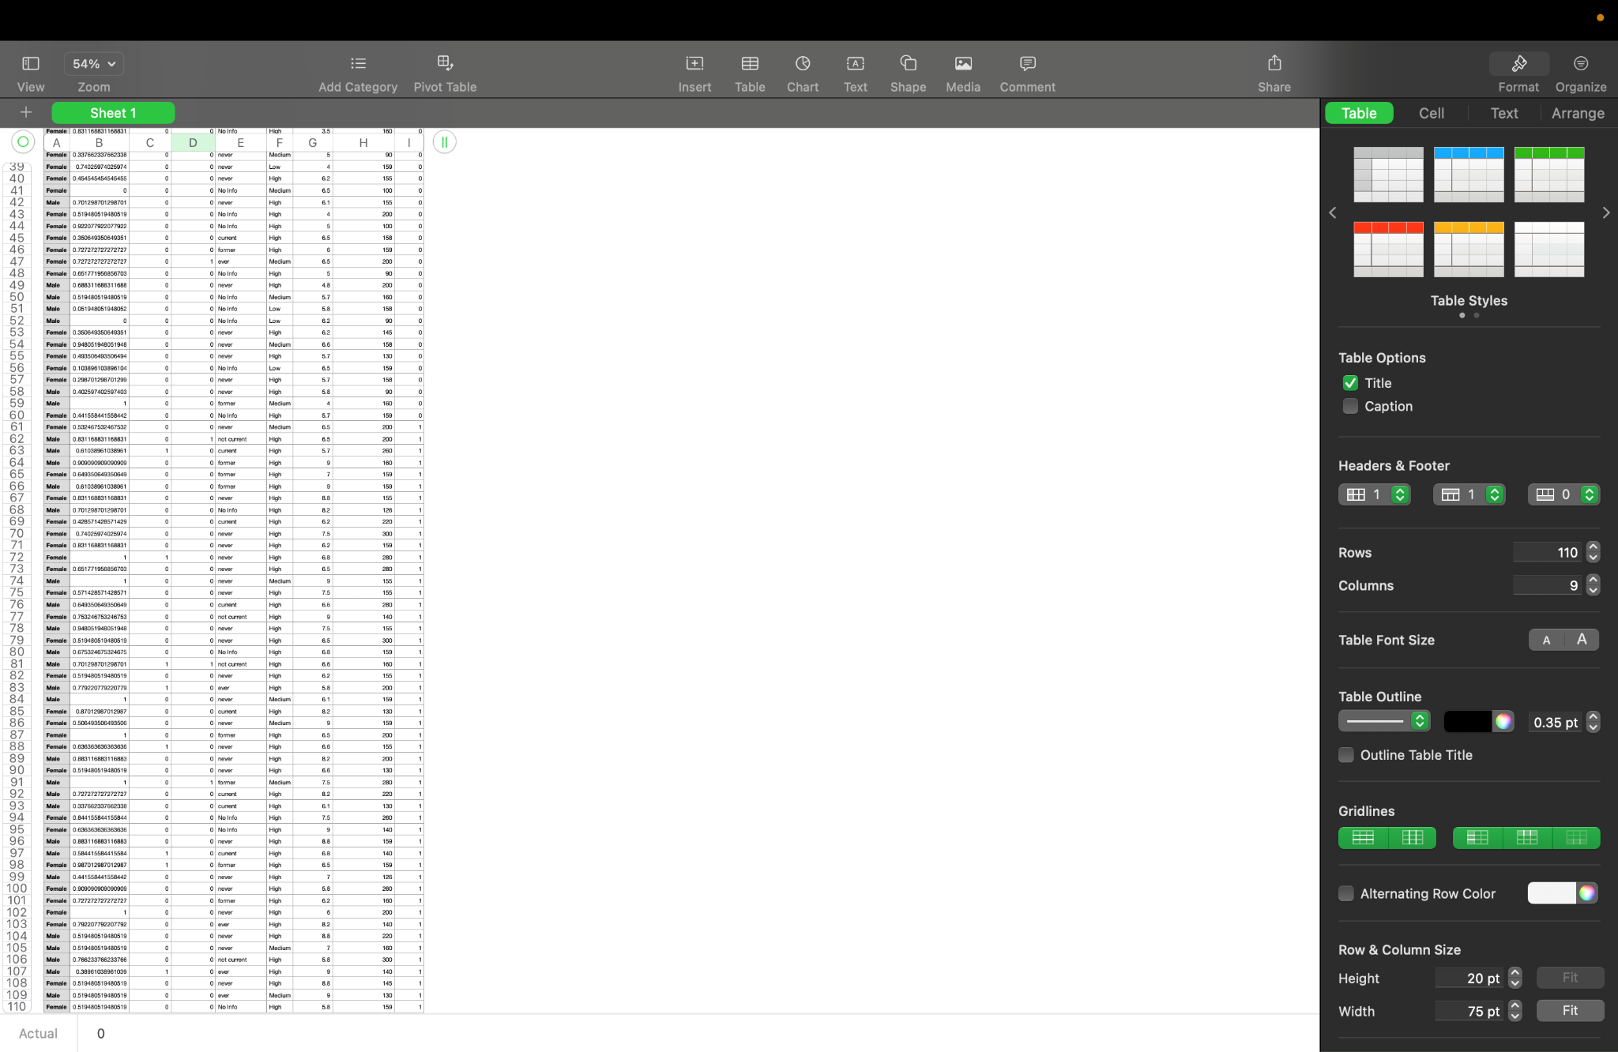

Fig: Exported dataset from R studio

After doing all the data processing we exported our text dataset from R studio.